Purpose
The purpose of this document is to provide a ‘template by example’. So, this is a copy of a small Photo Opportunity with all of the Trip Profile filled in and example photos. A blank Trip Profile is provided on page 2. So, using the example Trip Profile as a guide, fill in the blank Trip Profile. Also delete all of the example text and photos and add your contribution.
Trip Profile
Topic | Details
Trip Name | USA_Texas_Richardson_Prairie Creek Park
Short Description | This suburban park offers a nice waterfall and a nature walk.
Web Site | https://www.onlyinyourstate.com/texas/beautiful-blue-waterfall-tx/
Contributor/email | Sam Lucas / SamHoustonLucas@aol.com
Travel Time | From Dallas, about 20 minutes
Date trip taken | January 2021
Points of Interest | Waterfall, Wildlife
Address for Mapping Software | 2600 West Prairie Creek Drive, Richardson Texas.
Restrictions / Safety Issues | This is a city park in a middle income neighborhood. Normal safety precautions should be followed.
Entry Fee | None
Lodging Suggestions | N/A
Dining Suggestions | N/A
Best Shooting Time of Day | Early morning
Primary GPS Coordinate | Not available

Special notes
ID | Note
1 | There are 7 parking spots at 2400 West Prairie Creek Drive. Parking here will require a 150 yard walk to the waterfall.
2

Trip Profile
Topic | Details
Trip Name
Short Description
Web Site
Contributor/email
Travel Time
Date trip taken
Points of Interest
Address for Mapping Software
Restrictions / Safety Issues
Entry Fee
Lodging Suggestions
Dining Suggestions
Best Shooting Time of Day
Primary GPS Coordinate

Special notes
ID | Note
1
2

Overview
You can park at 2400 Prairie Creek drive and walk about 150 yards or you can park on the street at 2600 Prairie Creek Drive. This waterfall is fed by a creek, so the flow is dependent on recent rains.

Parking
Here is a picture of the 7 parking spots.
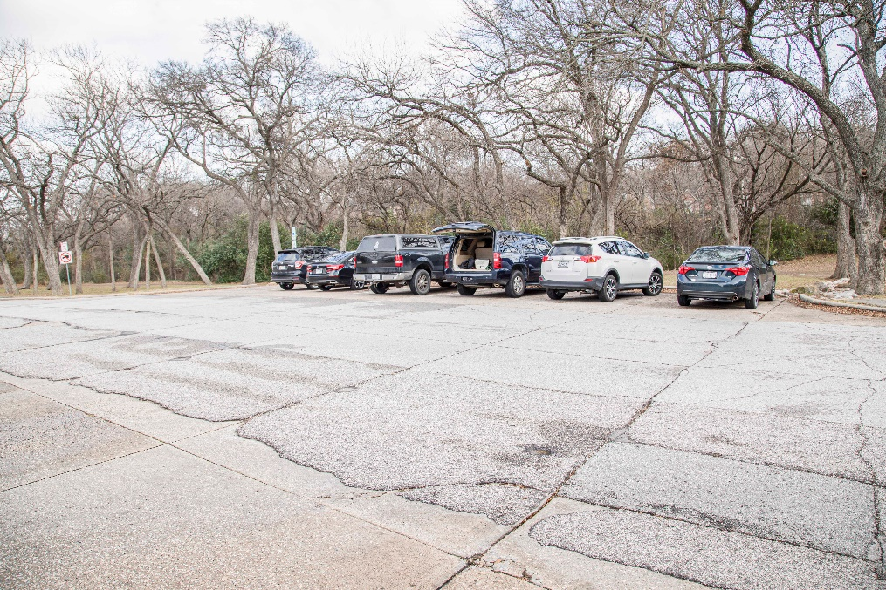

The Waterfall

The waterfall is about 50 yards from the street. There are limited opportunities from the street level. There is a nice rock walk way down to the creek bed. However, the creek bed can be very muddy. This image is from the creek bed.
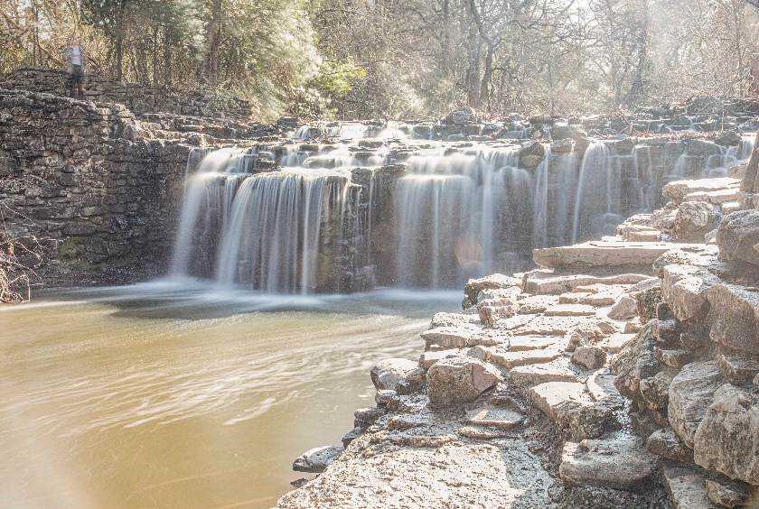
Here is an image from the street level by Lola Laird.

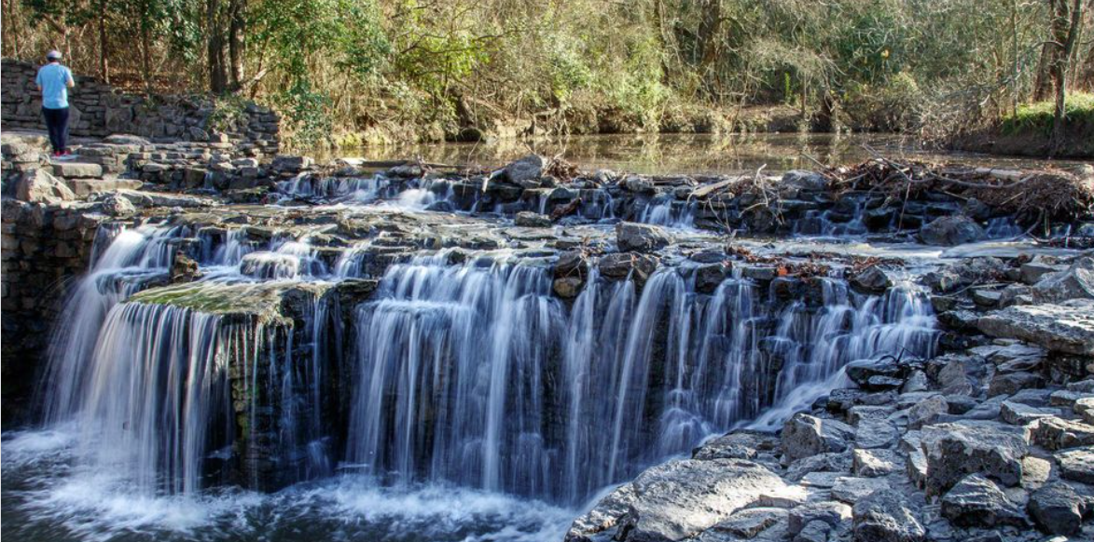

End of document

