Purpose
The purpose of this document is to identify points of interest for photographers. The document does not attempt to create an itenerary nor address logistical issues.

Trip Profile
Topic | Details
Trip Name | USA_Texas_Richardson_Prairie Creek Park
Short Description | This suburban park offers a nice waterfall and a nature walk.
Web Site | https://www.onlyinyourstate.com/texas/beautiful-blue-waterfall-tx/
Contributor/email | Sam Lucas / SamHoustonLucas@aol.com
Travel Time | From Dallas, about 20 minutes
Date trip taken | January 2021
Points of Interest | Waterfall, Wildlife
Address for Mapping Software | 2600 West Prairie Creek Drive, Richardson Texas.
Restrictions / Safety Issues | This is a city park in a middle income neighborhood. Normal safety precautions should be followed.
Entry Fee | None
Lodging Suggestions | N/A
Dining Suggestions | N/A

Special notes
ID | Note
1 | There are 7 parking spots at 2400 West Prairie Creek Drive. Parking here will require a 150 yard walk to the waterfall.
2
3

Continued on following pages

Overview
You can park at 2400 Prairie Creek drive and walk about 150 yards or you can park on the street at 2600 Prairie Creek Drive. This waterfall is fed by a creek, so the flow is dependent on recent rains.

Parking
Here is a picture of the 7 parking spots.
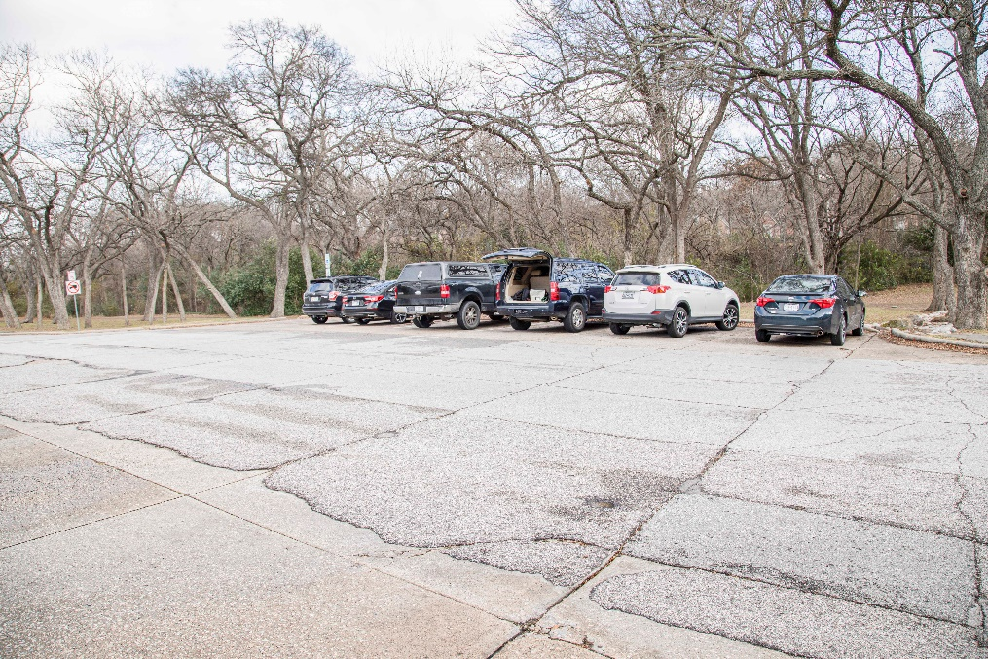

The Waterfall

The waterfall is about 50 yards from the street. There are limited opportunities from the street level. There is a nice rock walk way down to the creek bed. However, the creek bed can be very muddy. This image is from the creek bed.
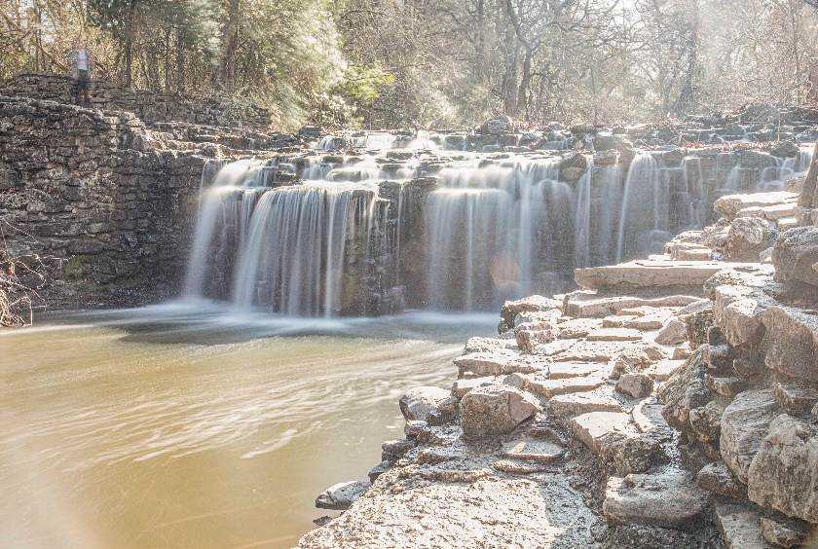
Here is an image from the street level by Lola Laird.

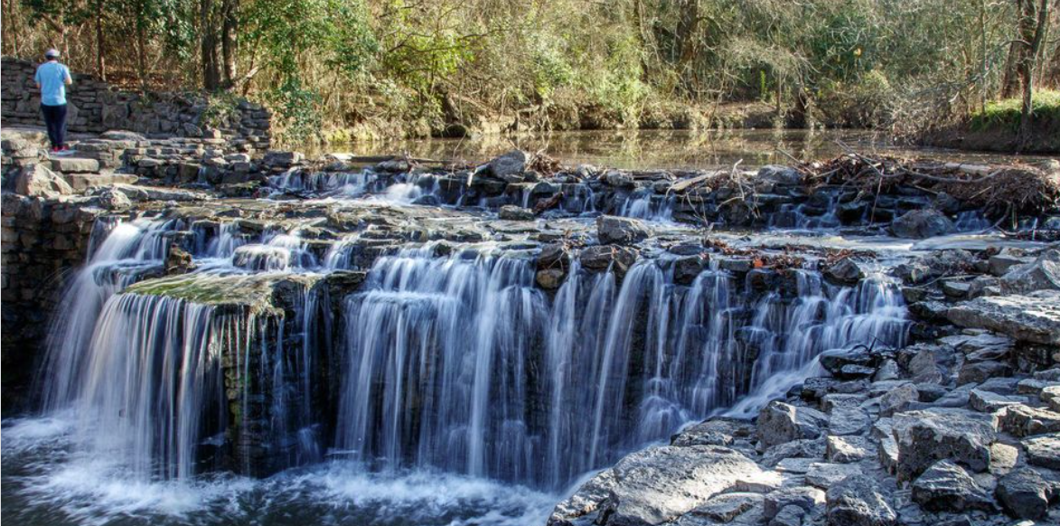

End of document

