Purpose
The purpose of this document is to identify points of interest for photographers. The document does not attempt to create an itenerary nor address logistical issues.

Trip Profile
Topic | Details
Trip Name | USA_Texas_Austin_Classic walk thru the University of Texas Campus
Short Description | This walk is focused on classic photo opportunities. It is a two mile downhill walk.
Website | https://maps.utexas.edu/#/utm
Contributor/email | Sam Lucas / SamHoustonLucas@aol.com
Travel Time | From the DFW area – 4 hours
Date trip taken | Jan 2021
Points of Interest | Architecture, street photography, fountains, landscape
Address for Mapping Software | 2323 San Antonio, Austin Texas  This is the University Coop parking garage
Restrictions / Safety Issues | Campus is very safe and open to the public.
Entry Fee | There is a reasonable parking fee.
Lodging Notes | There are many hotels available near the campus
Dining Notes | Campus has fast food dining at the Student Union on the West Mall and the Student Union adjacent to Gregory Gym.

Special notes
ID | Note
1 | At the end of the walk you can either walk back uphill or summon an Uber ride.
2 | The fountains are only turned on for 2 or 3 days at graduation.
3

Continued on following pages

Overview
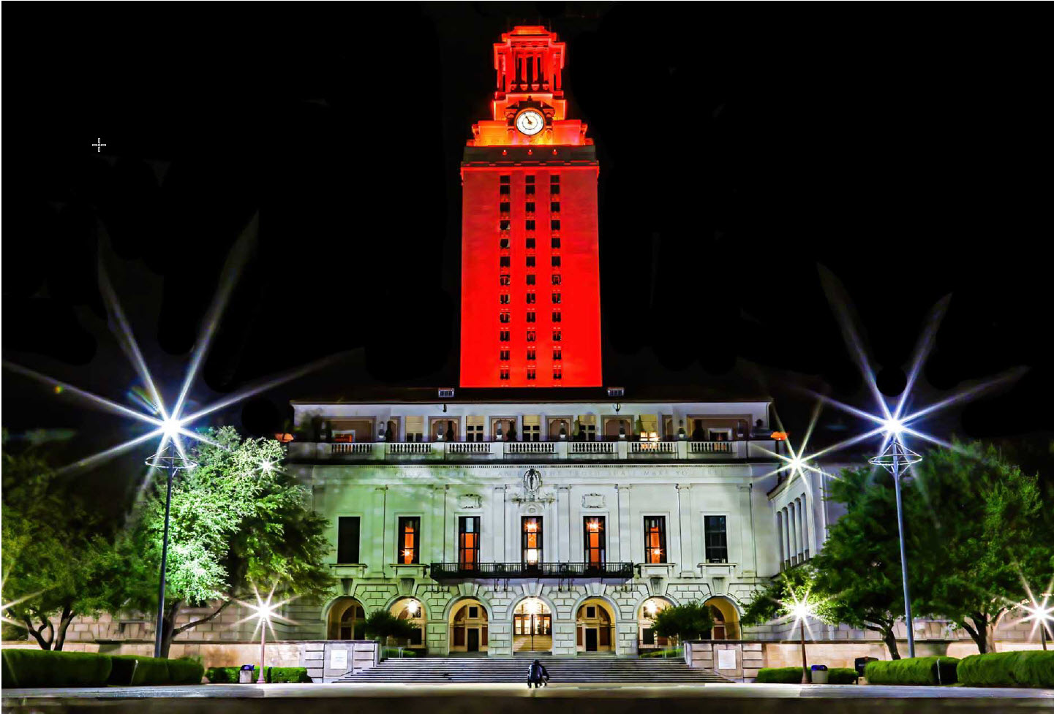

The campus of the University of Texas at Austin offers many photographic opportunities. Too many for a short article, but let’s take a ‘classic’ stroll so that you can get some excellent photos on your initial trip to the campus. Austin is very hot in the summer and the campus population is low. Think about taking this walk between November and April. If you are interested in flowing fountain shots, tour during graduation. Fountains are turned on only during graduation (3 days in May and December). However, during graduation, there will be many temporary stands that will ‘clutter up’ the Main Mall.
The easiest parking is at the CoOp parking garage at 2323 San Antonio. It is one block off Guadalupe. Consider going to the top to get roof top image of the food mall and the campus. As you stroll, consider going into some of the buildings to get a real ‘feel’ for student life.

Stop 1 – Photo Opportunity 1 - The roof of the University Coop parking garage
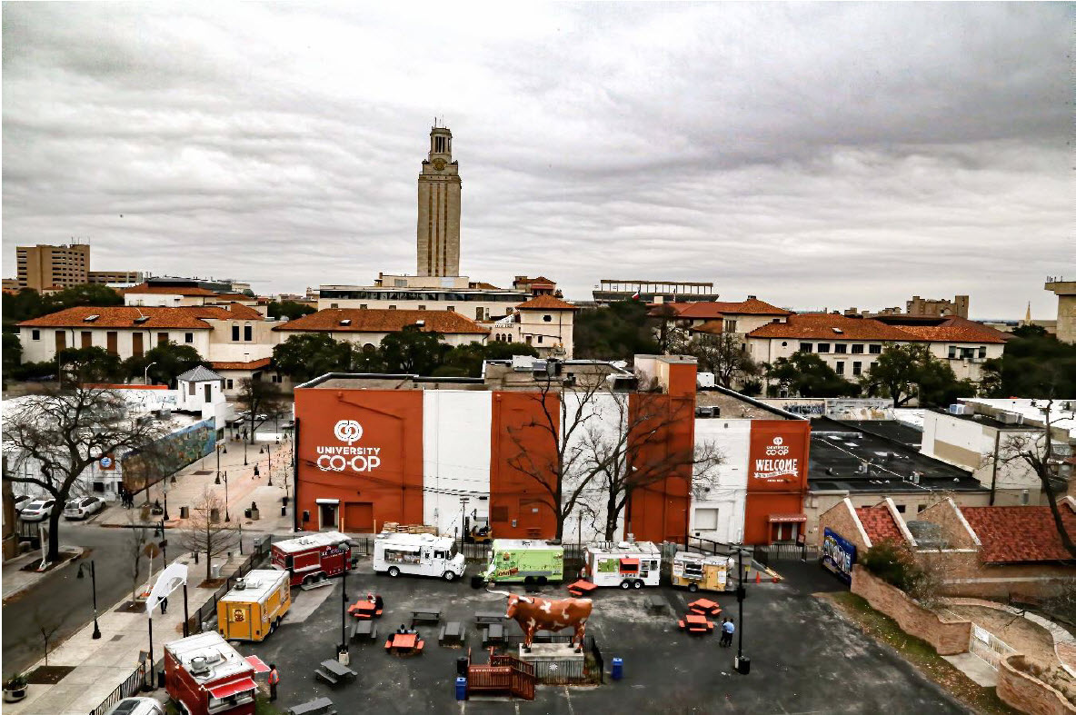

So, start at the University CoOp on Guadalupe. This section of Guadalupe is commonly called ‘The Drag’. Cross Guadalupe to enter the West Mall of the campus. An immediate opportunity presents itself as you frame up the Student Union (on the left) with the UT Tower. Walk 50 yards toward the Tower and you will be in front of the Academic Canter. Consider shooting the Greek Runners (a statue) from several angles (including from the rear).

Stop 2 – Photo Opportunity - West Mall
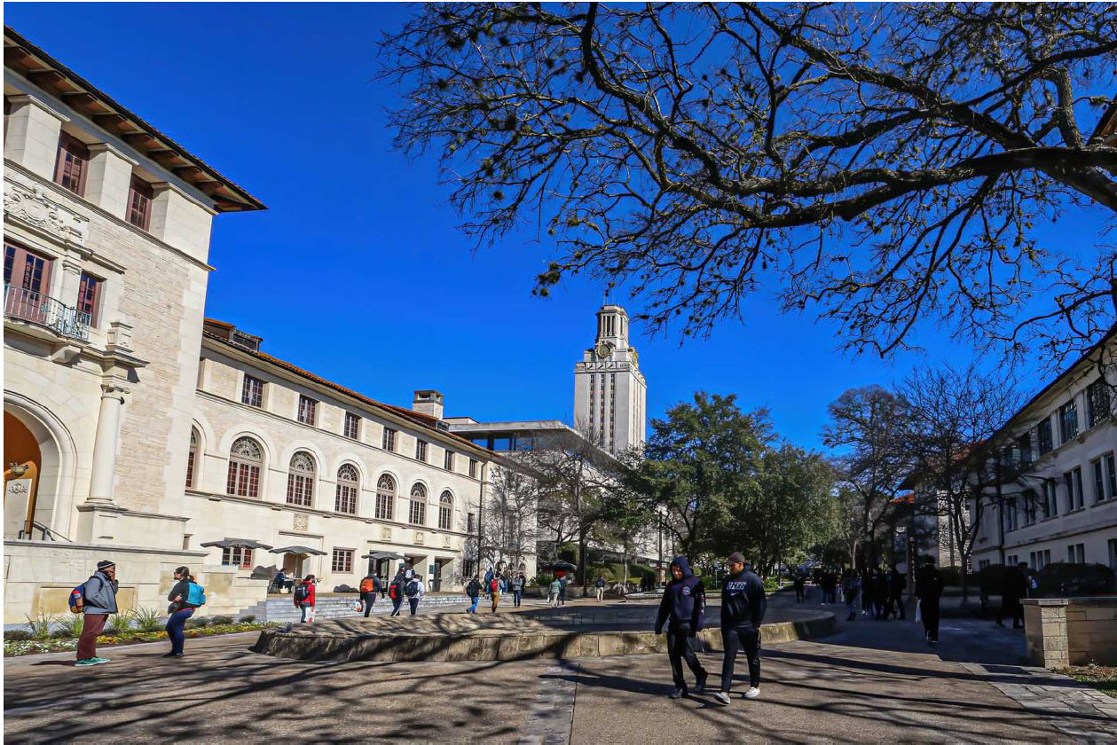
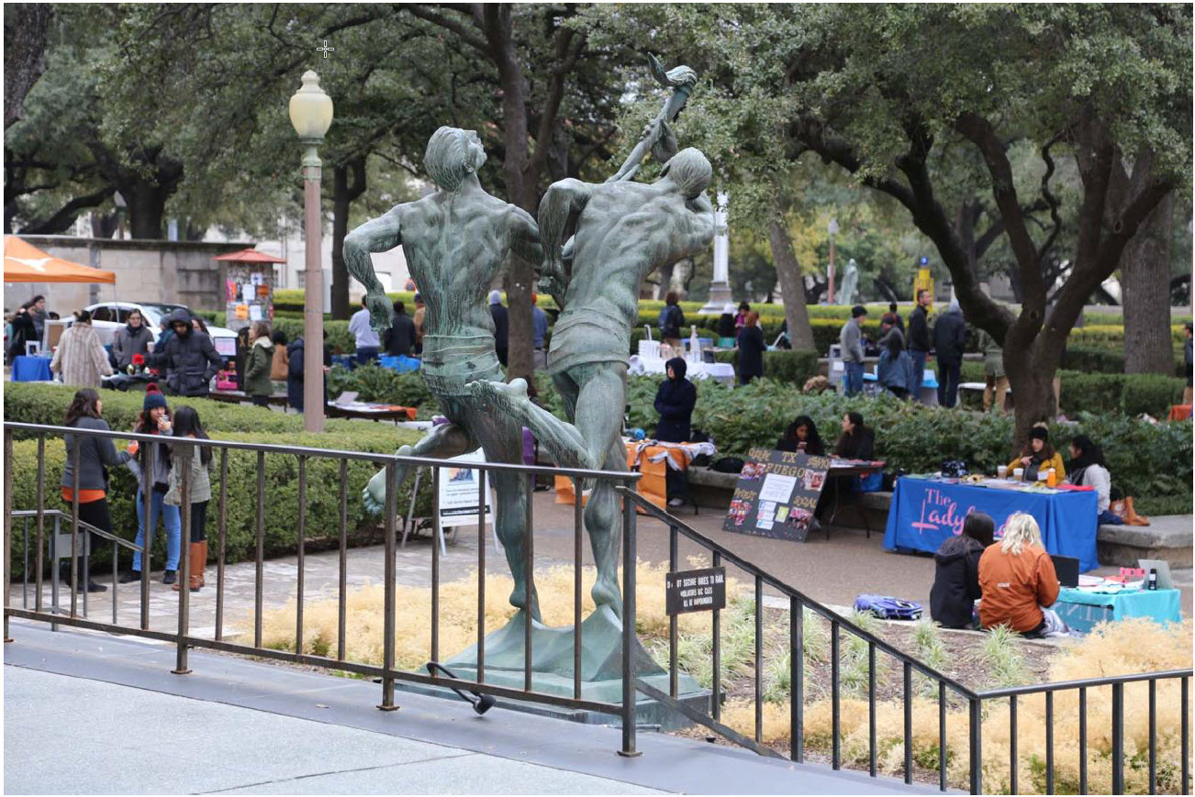

Stop 3 – Photo Opportunity - Main Mall
Continue with a slight jog to the right and you will enter the Main Mall. You will want several images of the Tower and the main building. Note the quote running across the top of the Main Building, ‘Ye shall know the truth and the truth will make you free’. Search the internet for information on tours of the Tower.

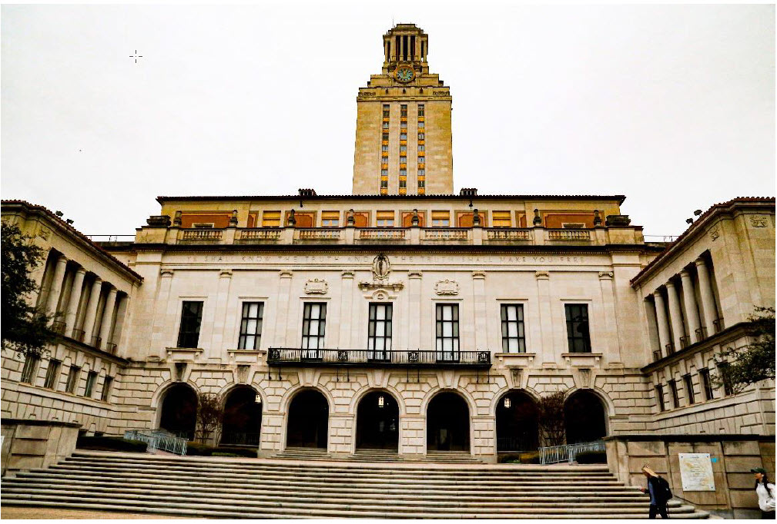
From the center of the main mall, turn around to see the oak trees of ‘The Six Pack’ (the six academic buildings along the south mall) as they frame up the view of the State Capitol of Texas. Walk down either side of the side mall (toward the Capitol) and look for squirrels and ‘niche’ shots of the buildings, the oak trees and students. Do not feed the students.
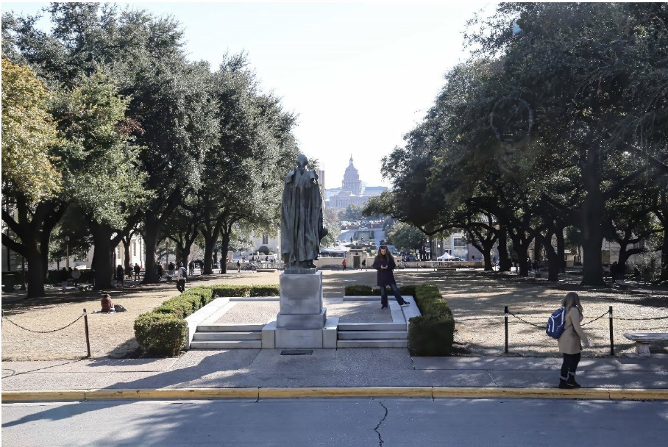

Stop 4 – Photo Opportunity - Littlefield Fountain

At the southern base of the South mall, you will find the Littlefield Fountain. This WW I Memorial was built in 1917. It can be a difficult target because of the shadows during the day. Looks for angles that minimize the shadows. Also, face the fountain with the Tower in the background and capture the fountain and the Tower. You are now on West 21st Street.

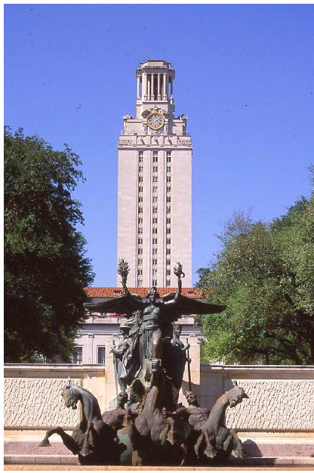
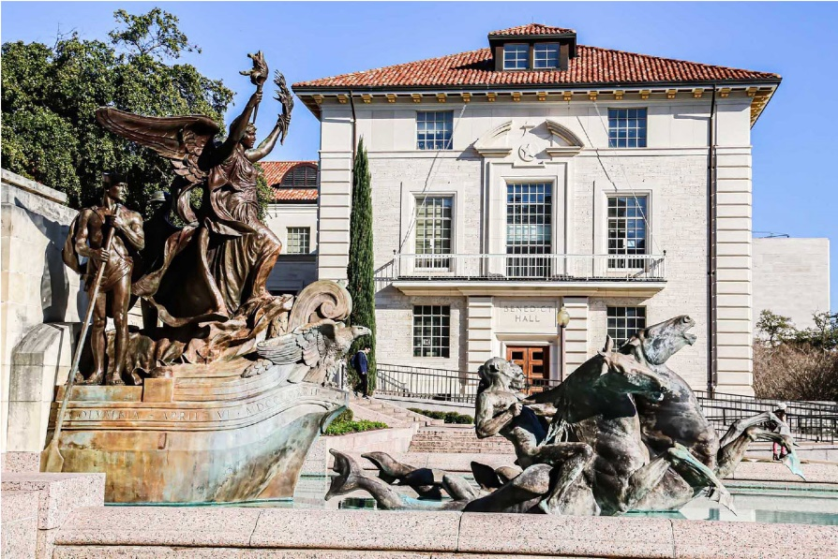

Stop 5 – Photo Opportunity - Graduate School of Business
Proceed east along the street (East 21st) and you quickly encounter the entrance plaza for the McComb Graduate School of Business. Note that this image is during the winter (bare trees). Notice that the orange building (in the image) is a reflection. Don’t expect the blue glass unless you arrive at sundown (or maybe if you pull out a ‘Blue and Gold’ filter).

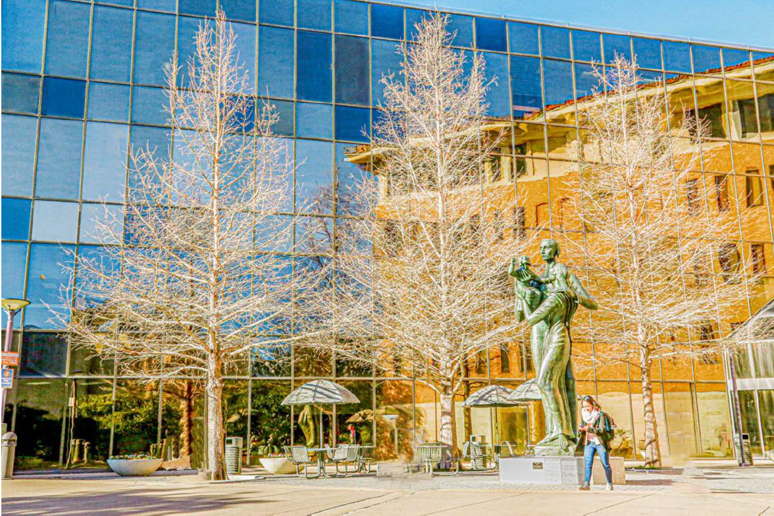

Stop 6 – Photo Opportunity – Memorial Stadium
Continue on East 21st and you reach Speedway. It used to be a street and is now a pedestrian walkway. To the left is Gregory Gym, a very large and old structure. Continue heading east along East 21st and you run straight into Memorial Stadium (yet another photo opportunity). Turn left to proceed north along San Jacinto. Immediately on the left is the Texas Exes Building which is alongside Waller Creek. Plenty of opportunities present themselves and the inside of the Texas Exes building is remarkable.

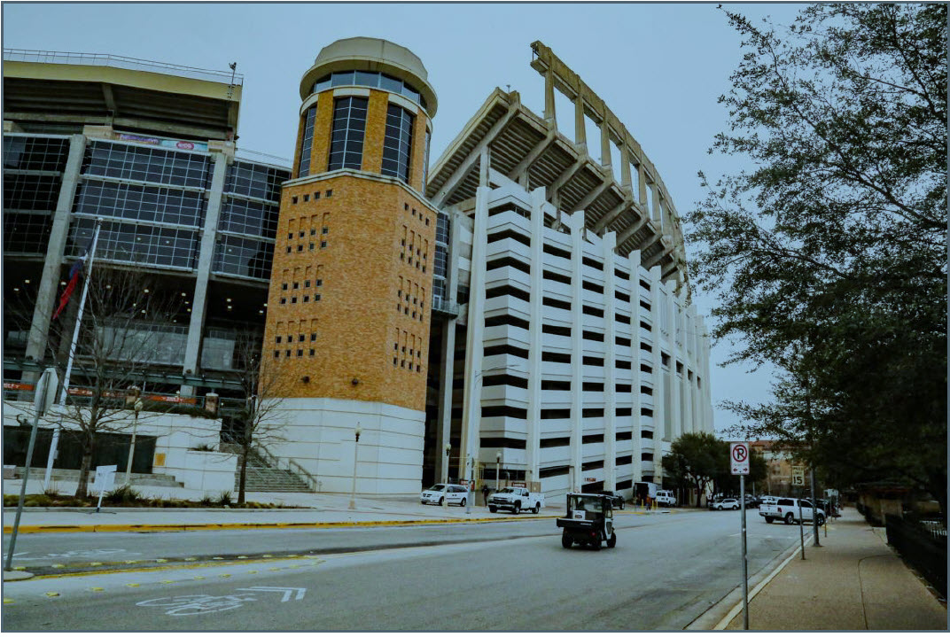
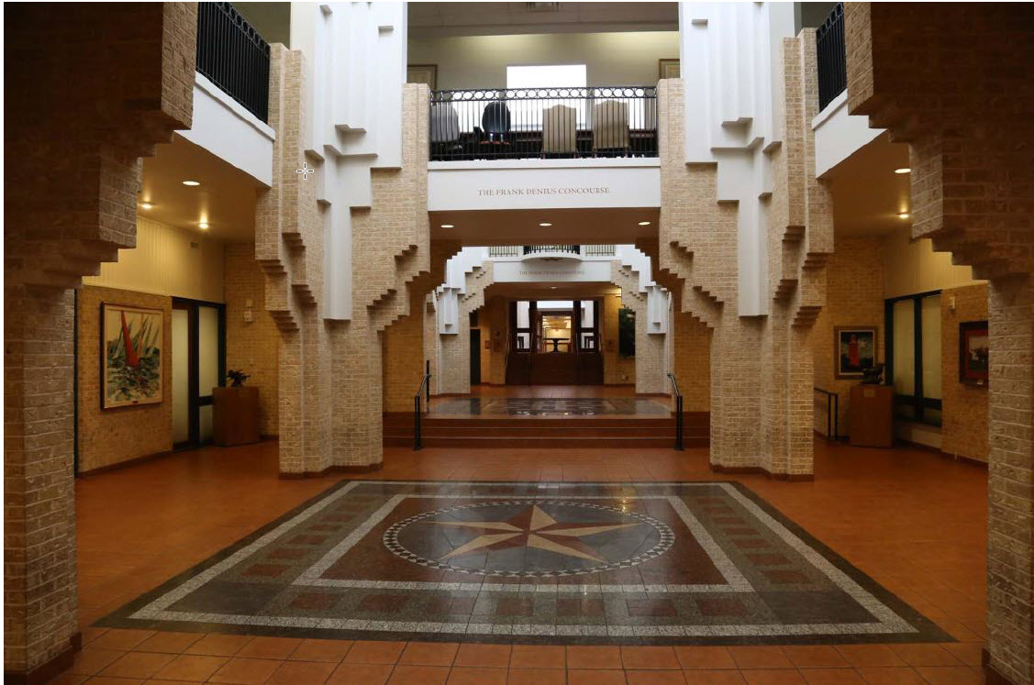

Stop 6 – Photo Opportunity – LBJ Library
Continue west along San Jacinto to the intersection with East 23rd (also called Deloss Dodds Way). Up to this point you have covered about two miles and you have been walking downhill. So, you could call Uber to take you back to the Co-op or turn west toward the Tower and begin walking back (uphill). Better yet, you may want to continue (east) over to the LBJ Memorial Library. It is in sight (to the east).

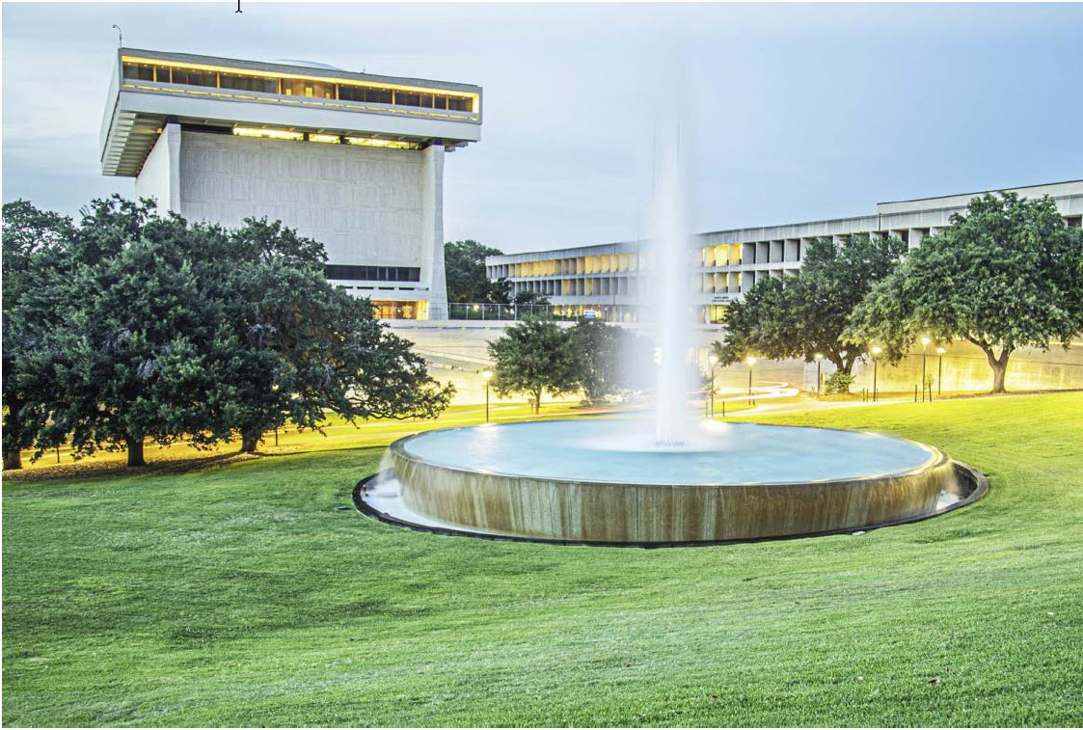

Conclusion
To finish your day, I suggest Scholtz’s Beer Garden at 1607 San Jacinto. It is the oldest beer garden in Texas and has been in operation since 1866. Just remember that you have seen only a small portion of the campus and there are many, many more opportunities to explore. Also remember that you are in Austin and that the State Capitol, Zilker Park, and Lady Bird Lake all offer great photo opportunities. I also suggest going online and printing out the UT map;
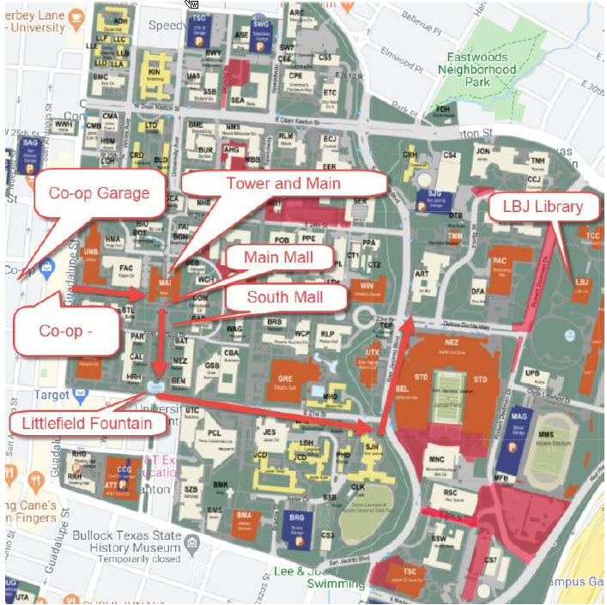

End of document

