Trip Profile
Topic | Details
Trip Name | USA_Texas_Fort Worth (Downtown)_Heritage Park  Plaza (on the River)
Short Description | Urban park on the Trinity River. Views of auto and pedestrian bridges, Community College, courthouse from river-level.
Web Site | https://www.dfwi.org/go/hp
Contributor/email | Chet Ciancarelli / crc.benbrook@sbcglobal.net
Travel Time | Five Minutes from Tarrant County Courthouse, Fort Worth
Date trip taken | Multiple
Points of Interest | Main St Bridge, Architecture of Tarrant Community College, Ripley Arnold Monument, cyclists, kayaks, River, ruins of old buildings.
Address for  Mapping Software | Parking lot at North end of N Taylor Street
Restrictions / Safety Issues | Normal precautions for urban park. Watch for cyclists on Trinity Trail.
Entry Fee | Must feed the parking meter when required
Lodging  Suggestions | Many options in Downtown FW
Dining  Suggestions | Many options in Downtown FW
Best Shooting Time of Day | Mornings and Evenings
Primary GPS Coordinate | 32.758725, -97.337408

Special notes
ID | Note
1 | Lots to see at river level. Plenty to explore on both sides with ½ mile each way. You can also go up to street level for elevated views.
2 | Ripley Arnold was the founder of Camp Worth in 1849 which later became Fort Worth.
Main St Bridge from Trinity Trail
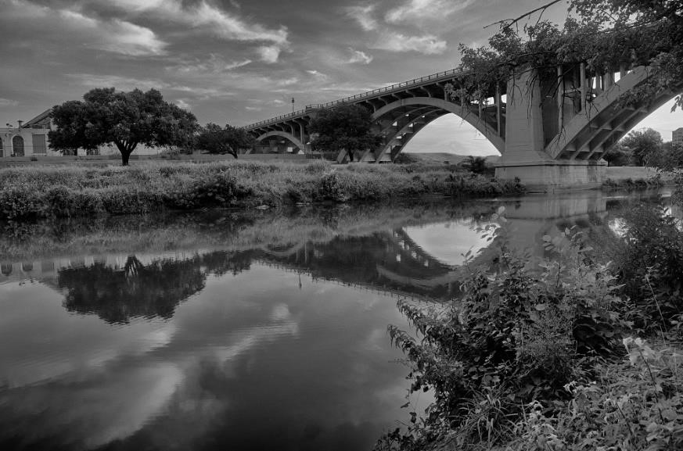

Maj Ripley Arnold and Tarrant County College
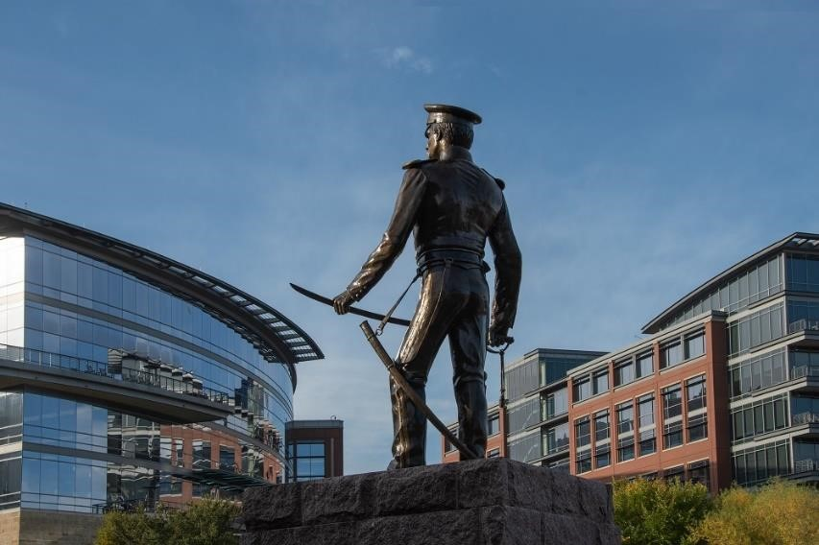

Main St Bridge and Tarrant Courthouse
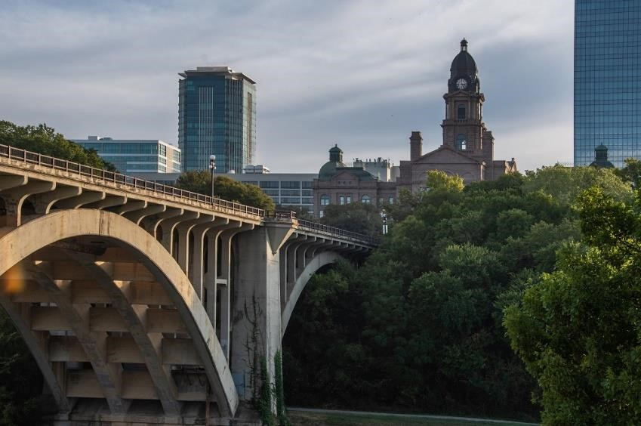

Old Factory North West Corner of Main St and Trinity River (from river level)
