Purpose
The purpose of this document is to identify points of interest for photographers. The document does not attempt to create an itinerary nor address logistical issues.
Trip Profile
Topic | Details
Trip Name | The “Rookery” at UT Southwestern Medical Center (UTSWMC)
Short Description | A great place for bird photography in the heart of Dallas’ Medical District –See Special Note # 4 (below) for a list of birds.
Website | https://www.google.com/maps/place/UTSWMC+Rookery/@32.8136171,-96.8459502,17z/data=!3m1!4b1!4m5!3m4!1s0x864e9c1ad1f1ce5d:0x83335176779bb1b!8m2!3d32.8136171!4d-96.8437562
Contributor/email | Clinton Kemp, ck@clintonkemp.com
Travel Time | Approx. 5 miles NW of Downtown Dallas
Date trip taken | Spring / Summer 2020
Points of Interest | See Special Note # 4 (below) for a list of birds.
Address for Mapping Software | 2000 Inwood Rd, Dallas, TX 75235  3 parking spaces (including 1 handicap) located near the corner of Campus & UT Southwestern Dr. Otherwise there is a visitor parking lot off Campus closer to Harry Hines.
Restrictions / Safety Issues | You can walk around the perimeter of the 4-acre site, however you are not allowed to enter the woodland. See Special Note # 5, below.
Entry Fee | Free
Lodging Notes | If traveling from outside the Metroplex, there are nearby hotels along Interstate 35E W between Mockingbird and Oak Lawn Ave.
Dining Notes | See Appendix A.
Best shooting time of day | Morning and Evenings
Primary GPS Coordinate | 32.816204, -96.843927

Special notes
ID | Note
1 | Watch out for bird droppings from nests above. Watch your step, too!
2 | Late Feb-Early April provide best views before trees are fully leafed out. June is ideal time to photograph baby chicks.
3 | Stay out of the wooded area. Walk around the perimeter of the sanctuary.
4 | This has been a known breeding ground and nesting site for several gregarious species of migratory birds (active nests February-September) since at least 1963. Birds you can find: Great Egrets, Cattle Egrets, Snowy Egrets, Black-Crowned Night Heron, Little Blue Herons, Tri-colored Herons, Anhingas and American White Ibis can be found on this 4-acre site between February and September.
5 | Wear good shoes as most of the area is grass, but there can be some muddy areas. There is a segment of asphalt walkway, but it is in poor condition as of summer 2020. Try to avoid walking underneath nests to avoid bird droppings hitting you and your equipment.

Overview / Directions
Take I35W E and exit Inwood Rd and turn East (right if coming from downtown or turn left if coming from North Dallas. Turn right at Southwestern Medical Ave. Then take an immediate left onto Campus. There are three visitor parking spaces on your right. If none are available proceed on Campus until you find the Visitor parking lot on the right. There is typically a fee for the visitor lot (But it has been free since the Pandemic began). | Below is an overview map of area (see red pin drop for UTSWMC Rookery):  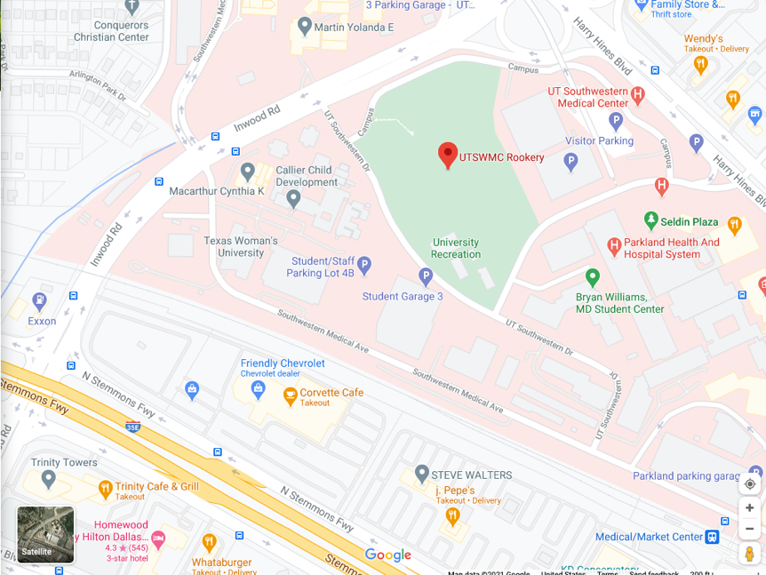  Map below shows parking spaces, alternate parking lot and parking garage for “birds-eye view”.  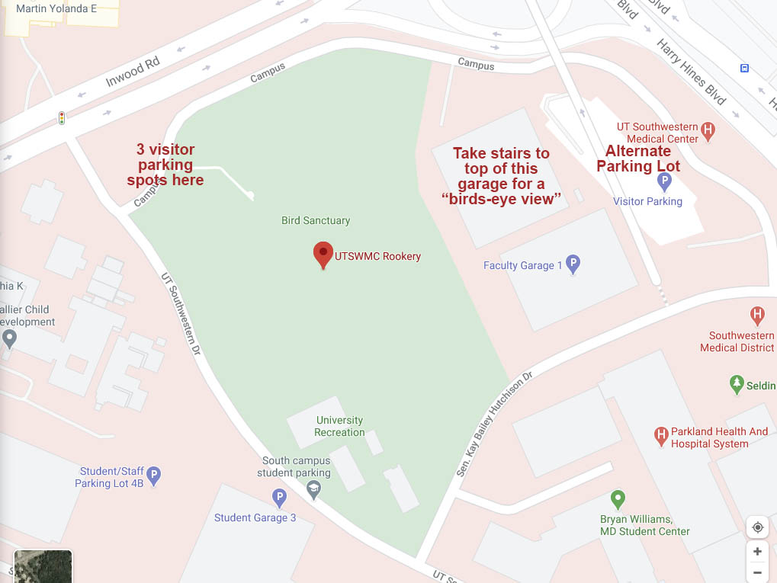

Great Egrets, Cattle Egrets, Snowy Egrets, Black-Crowned Night-Herons, Little Blue Herons, Tricolored Herons, Anhingas and White Ibises are most common. The star of the show and most populous species is the Great Egret. They are beautiful with their breeding plumes and bright green lores (skin on face) that develop while breeding. You may also observe Great Egrets doing courtship displays such as stretching their necks toward the sky, raising their plumes, preening their wings and bobbing up and down. Late February through March are great times to photograph birds building nests and mating before the trees fully leaf out. April to June is a great time to photograph baby chicks. The timing of peak nest activity varies by species with Egrets among the first to get started. By late September, Cattle Egrets are the only species remaining and will be gone by October. Morning and late afternoon is when the birds are most active and a great time to capture birds in flight. Great Egrets are constantly flying back and forth from the site in the direction of the Trinity River, where they catch fish and transport material for their nests. Climbing the stairs to the top deck of a parking garage on the northeastern side is a great place to get a “birds-eye view” of the entire site. Some nests closest to the garage give you an opportunity to photograph eggs, baby chicks and other activity inside the nests. Be aware: As the summer heats up and the bird population swells, a strong ammonia odor permeates from the site and bird droppings fall like rain.

Stop 1 – Photo Opportunity 1

Walking around the perimeter of the site, below are some photos I took that illustrate the variety of birds you can capture.

1st row: Great Egret Breeding Behavior, Great Egret, Black-crowned Night Heron
2nd row: Black-crowned Night Heron, Cooper’s Hawk, White Ibis
3rd row: White Ibis, Cattle Egret, Great Egret
4th row: Anhinga, Cedar Waxwing, Snowy Egrets mating

Scroll down to see the 4 rows of photos
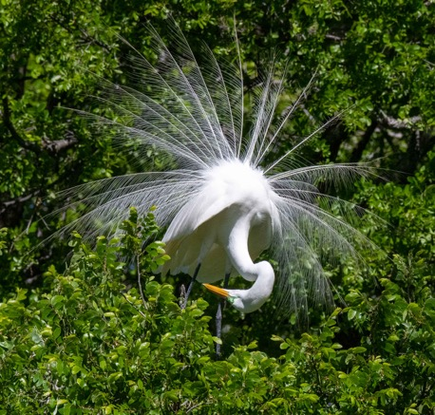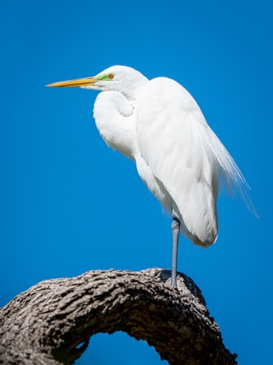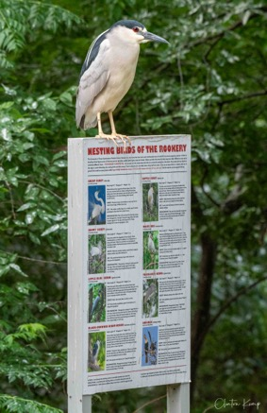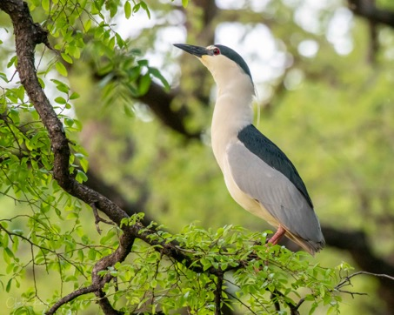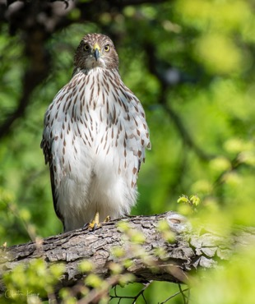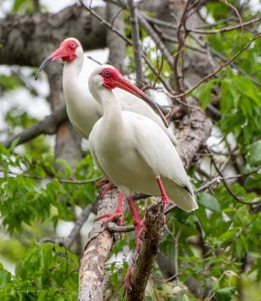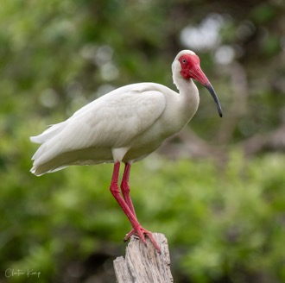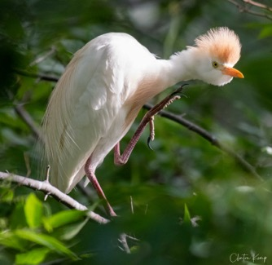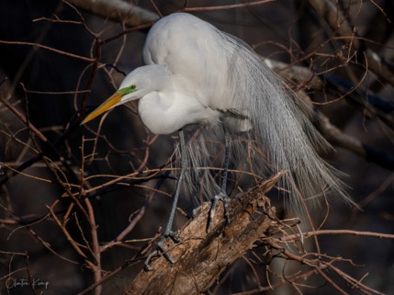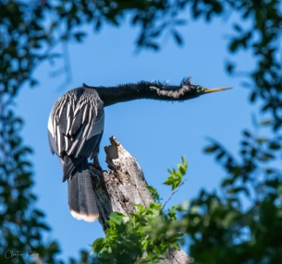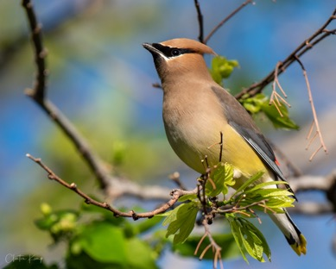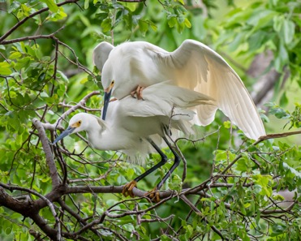

Stop 2 – Photo Opportunity

From the top of the parking garage located on the northeastern side of the site, you can photograph birds atop trees, flying to and from nests, as well as get shots of eggs, chicks and other activity inside nests.
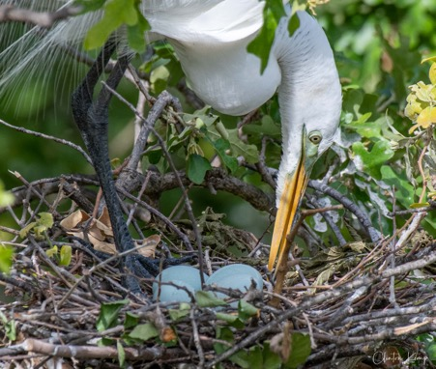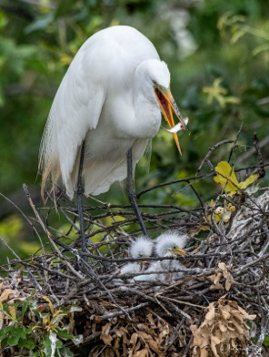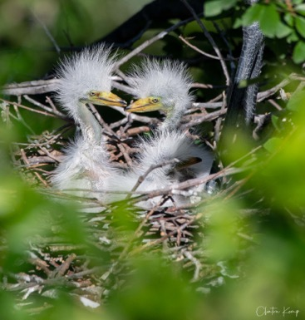

Appendix A – Restaurant / Shopping Suggestions

Nearby Restaurants:
The original Sonny Bryan’s Smokehouse – 2202 Inwood Rd
Social Pie (Pizza) – 5855 Maple Ave.
Maple & Motor (Burgers) – 4810 Maple Ave.
Ojeda’s Tex-Mex – 4617 Maple Ave.
In-N-Out Burger, Raising Cain’s Chicken and Chipotle located near Maple & Mockingbird
Nearby Shopping:
Competitive Cameras – 2025 Irving Blvd
Don’s Photo Equipment – 2731 Irving Blvd

End of document

