Purpose
The purpose of this document is to identify points of interest for photographers. The document does not attempt to create an itenerary nor address logistical issues.

Trip Profile
Topic | Details
Trip Name | USA_Texas_Caprock Canyons State Park
Short Description | Landscape and wildlife photo opportunity at Caprock Canyons
Website | https://tpwd.texas.gov/state-parks/caprock-canyons
Contributor/email | Alan Daniel alan.w.daniel@icloud.com
Travel Time | Approximately 5 hours from Dallas area to the State Park
Date trip taken | August 2020
Points of Interest | Landscapes, opens plains, red rock canyons, local wildlife, including the Texas State Bison Herd, and interesting small towns.
Address for Mapping Software | 850 Caprock Canyon Rd. Quitaque, TX 79255  Latitude: 34.410296  Longitude: -101.053264
Restrictions / Safety Issues | Follow State Park rules - Don’t play with the wildlife  Take plenty of water on hikes
Entry Fee | $5 or a State Park Pass
Lodging Notes | Lodging limited in Quitaque and Turkey – Recommend Hotel Turkey  https://hotelturkeytexas.com/
Dining Notes | Hotel Turkey for Lunch or Dinner – Live Music and Patio Bar  For BBQ try TC’s Ponderosa in Dickens Texas

Special notes
ID | Note
1 | Spring and Fall are best times to visit – Summer can be very hot
2 | Check out the local small towns for additional photo opportunities
3

Continued on following pages

Overview
Overview of the route from Dallas area to the State Park.  Your drive will take you through Denton, Decatur, Bowie, Wichita Falls, Quanah, Childress and Turkey | You might want to check out the internet for possible interesting stops in some of the towns along the way, like the petrified gas station in Decatur or the World’s Largest Bowie Knife in Bowie

Stop 1 – Photo Opportunity 1
Wide open landscapes with red rock formations. Most can be seen on the drive throught the park. They are lots of places to park and get out for a short walk or a long hike.
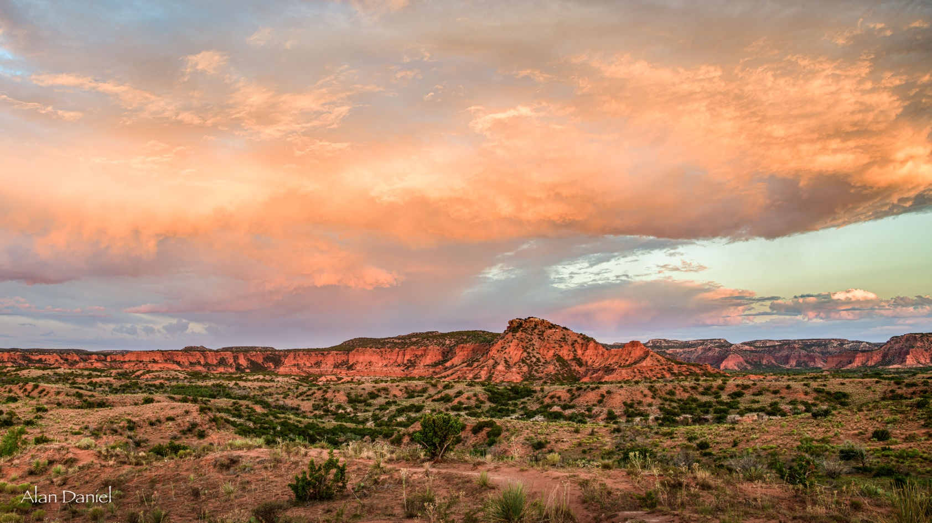
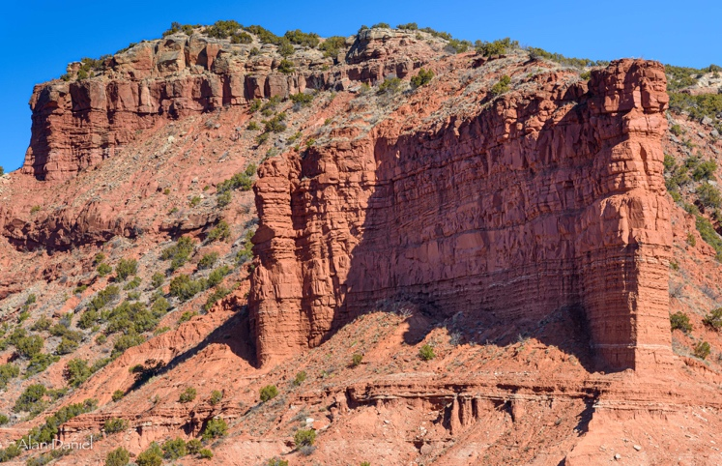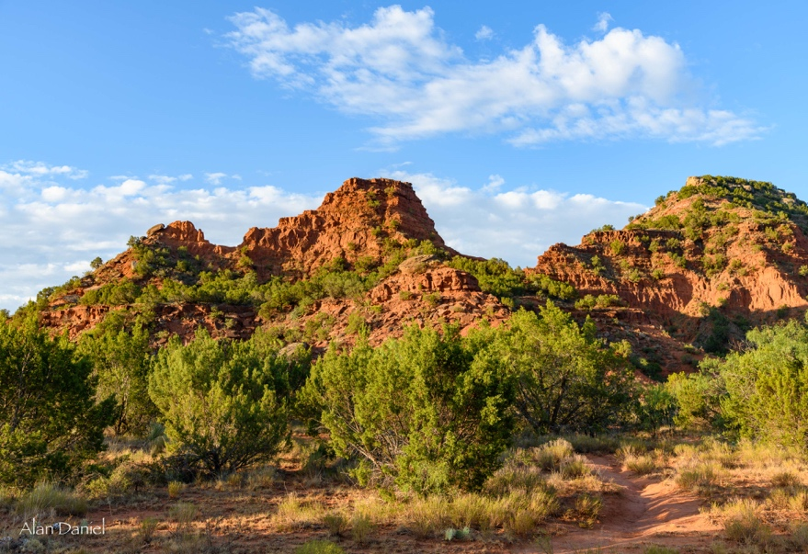

Stop 2 – Photo Opportunity
Caprock Canyon’s is also know as the home to Texas State Bison Herd as well as other wildlife.

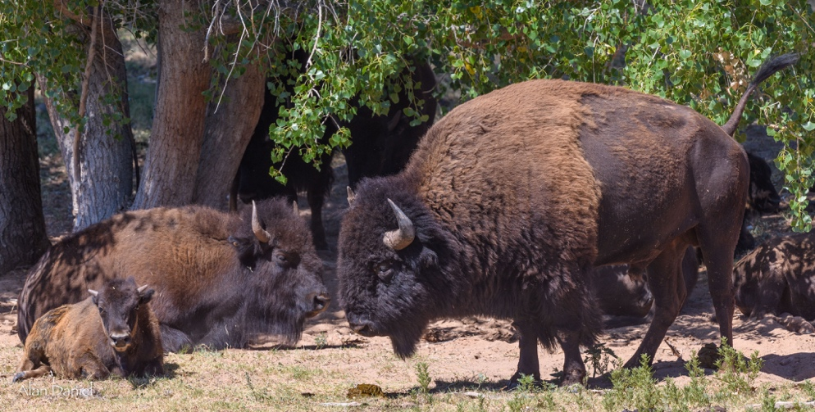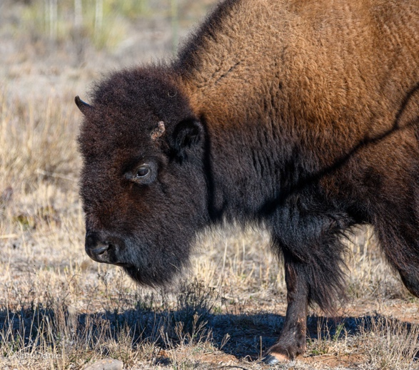

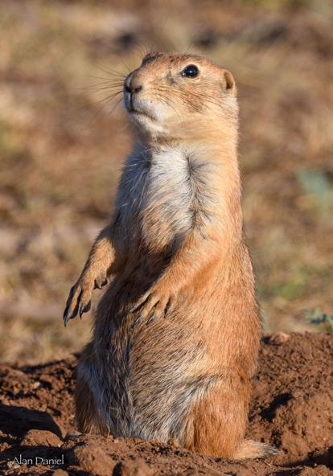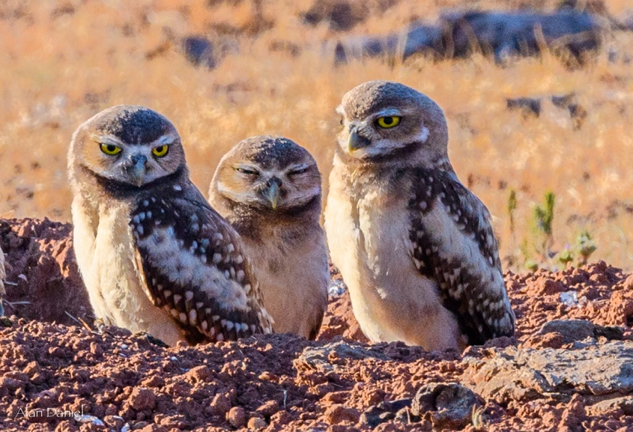
Appendix A – Lodging – Restaurant

Hotel Turkey www.hotelturkeytexas.com

Hotel, Restaurant and an outdoor patio with a bar and live music on the weekends.

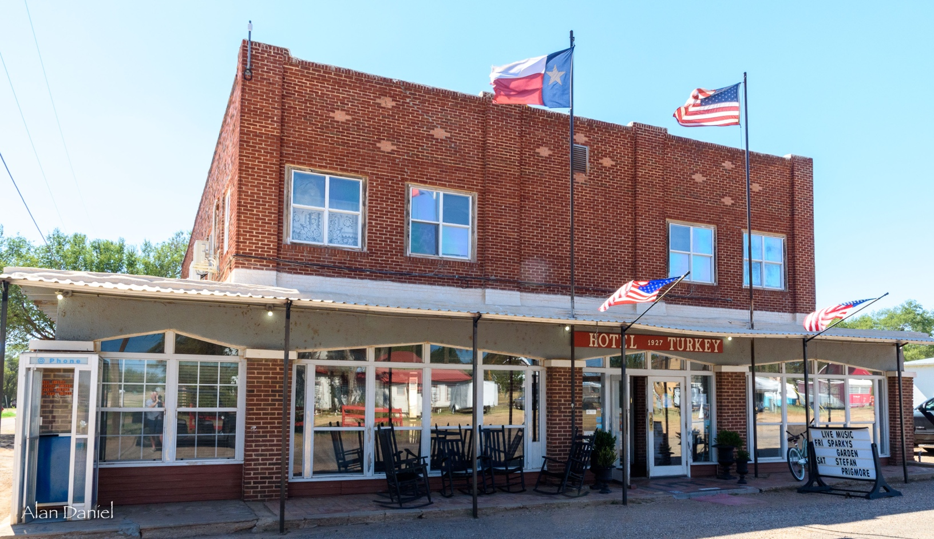

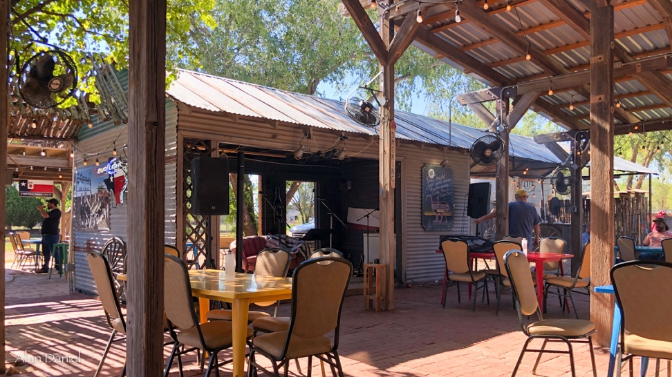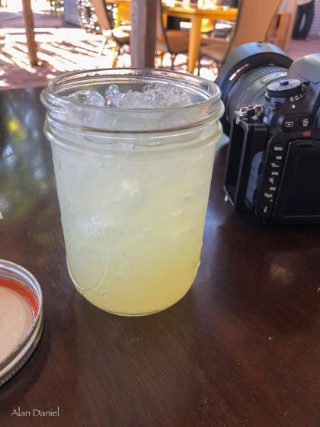

End of document

