Purpose
The purpose of this document is to identify points of interest for photographers. The document does not attempt to create an itenerary nor address logistical issues.

Trip Profile
Topic | Details
Trip Name | USA_Texas_Sherman_Hagerman National Wildlife Refuge
Short Description | This is a flat prairie land refuge located on the south side of Lake TexOma.
Web Site | https://www.fws.gov/refuge/hagerman/  Activities Calendar: https://www.friendsofhagerman.com/activities
Contributor/email | Sam Lucas / SamHoustonLucas@Aol.com
Travel Time | From Dallas, the drive time is about 1.5 hours
Date trip taken | 2021 01 10
Points of Interest | Wildlife (waterfowl, geese in winter)
Address for Mapping Software | Hagerman National Wildlife Refuge
Restrictions/ Safety Issues | This is federal land. Hunting is regulated (permits required). Fishing is allowed (check on permit requirements). Oil well pump jacks are scattered throughout the refuge. You can become very isolated very quickly so take appropriate safety precautions.
Entry Fee | None
Lodging Notes | Lodging is easily available, but this is really a day trip from either Dallas or Fort Worth.
Dining Notes | Nothing is available at the refuge. You would have to travel about 10 miles back to Sherman.

Special notes
ID | Note
1 | There is no camping at the refuge and it closes at sunset.
2 | Winter is the best time to visit. Geese come and go from the refuge.
3 | There are porta potties at the refuge headquarters and at the day use area (see image below).
4 | Periodically, the refuge is closed during feral hog hunts. Check the web site.

Overview
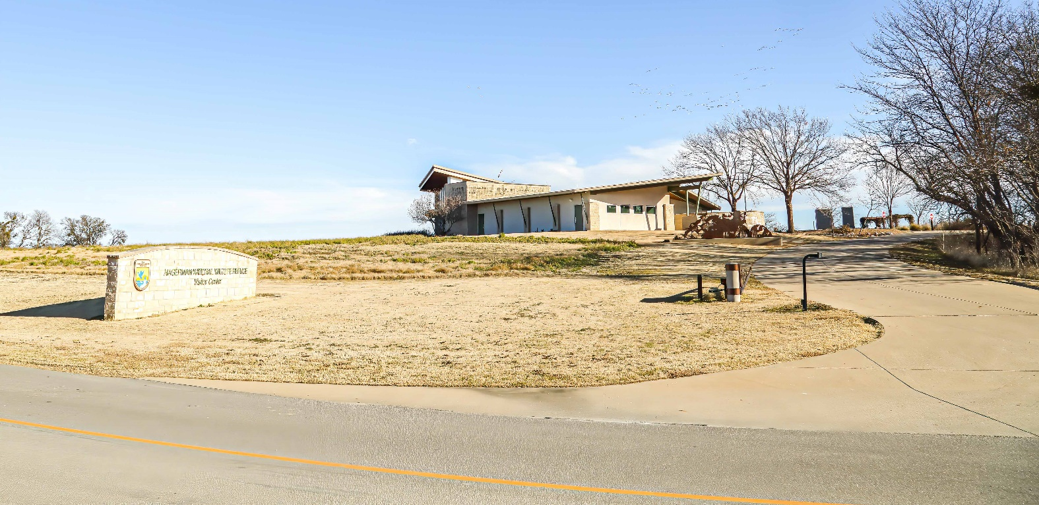

Above: This is the entrance to the Refuge.
Below: This is the back of the refuge headquarters.
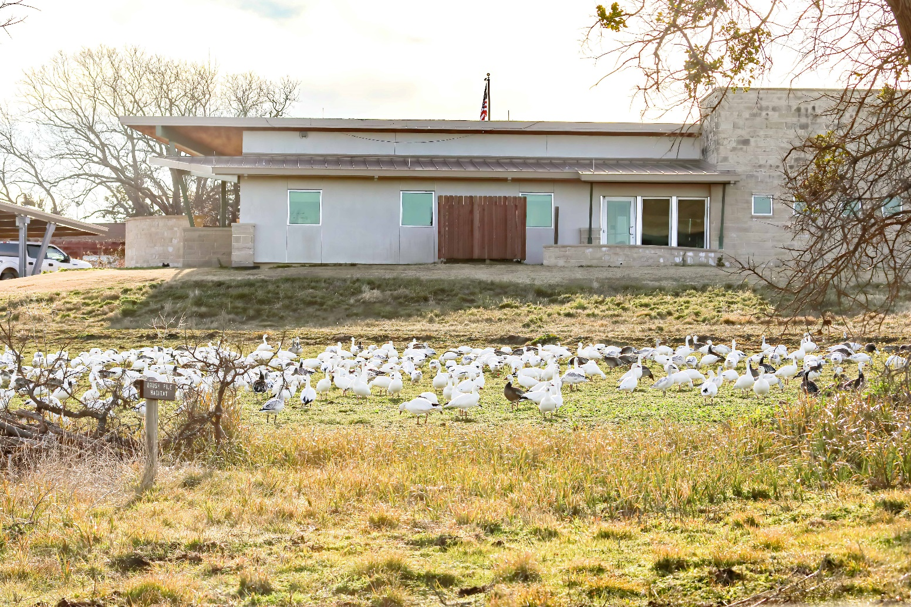

Photo Opportunity – Crusie thru wetlands
The refuge has many nice hard pack roads. There are one lane roads that take you out into the lake. They also have ‘Auto Tour’ signs marking a trial thru these roads.
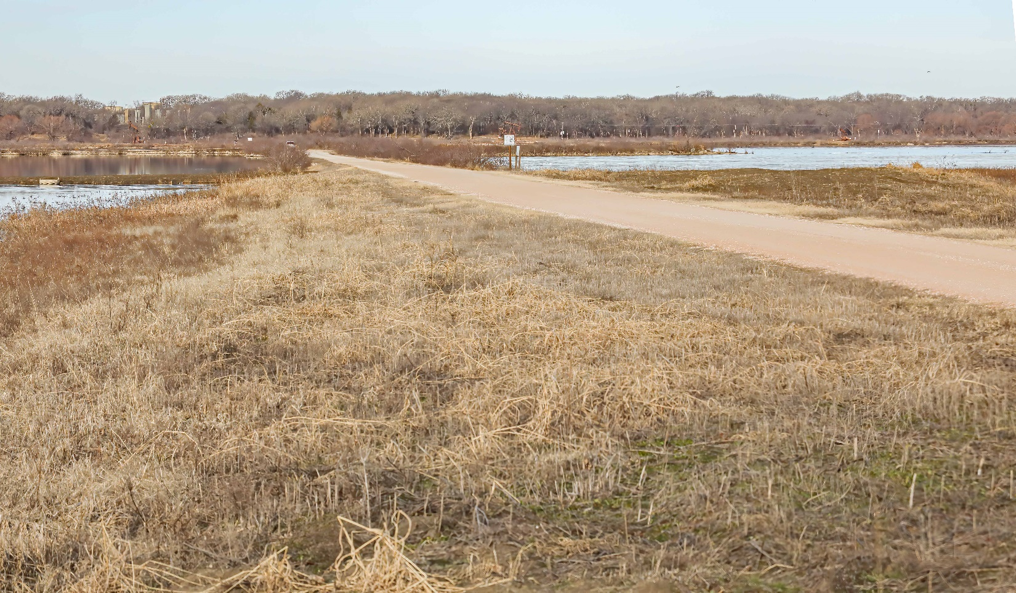

Big Mineral Day Use Area
The Big Mineral Day Use Area is located on Wildlife Road at a creek crossing. It has porta-potties.
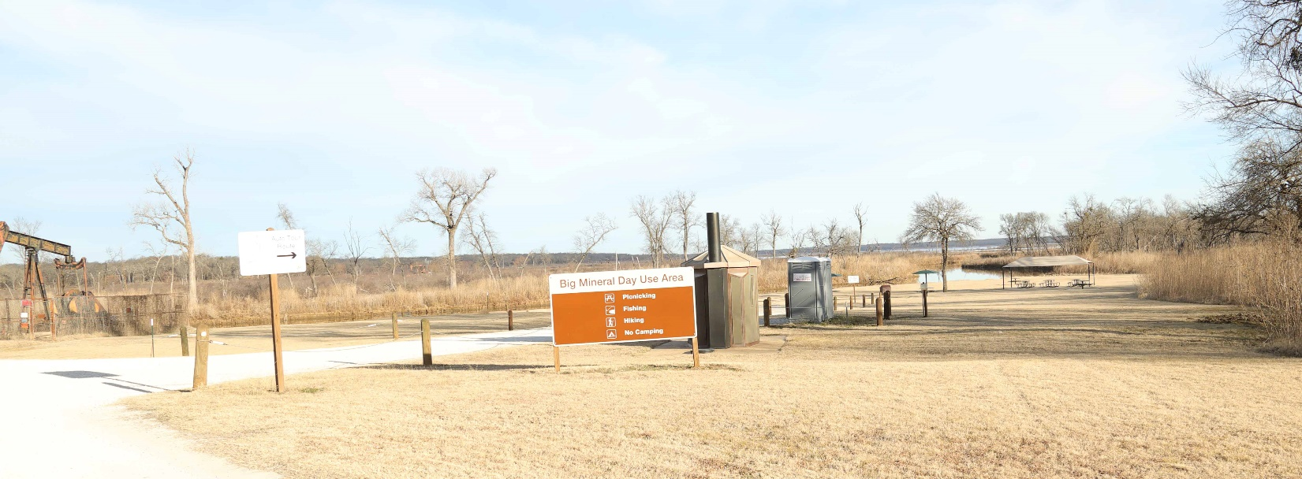

Hiking Trails
For more information: https://www.fws.gov/refuge/Hagerman/visit/activities/hiking.html

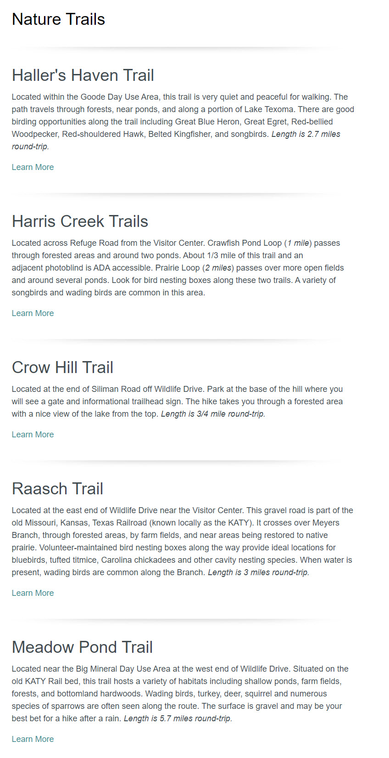

Sample images
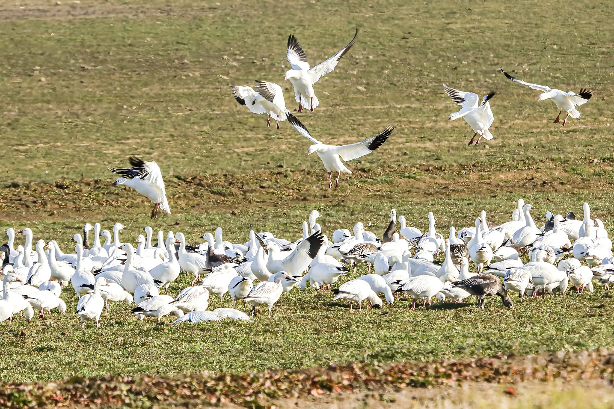
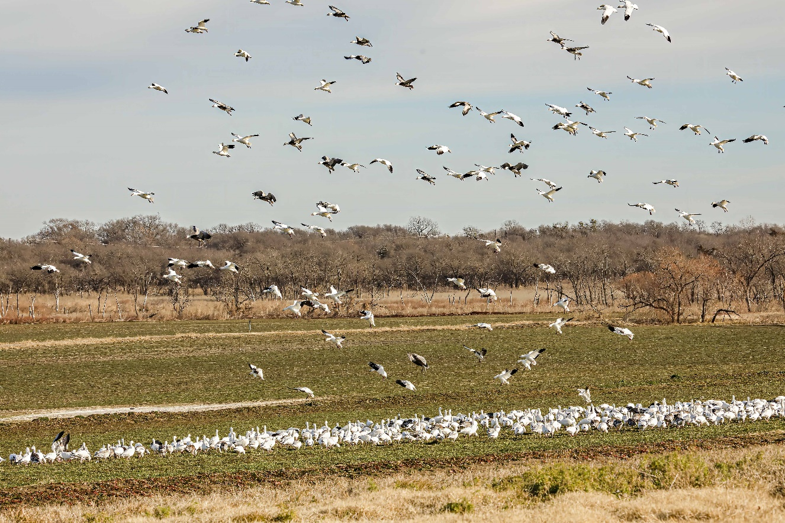
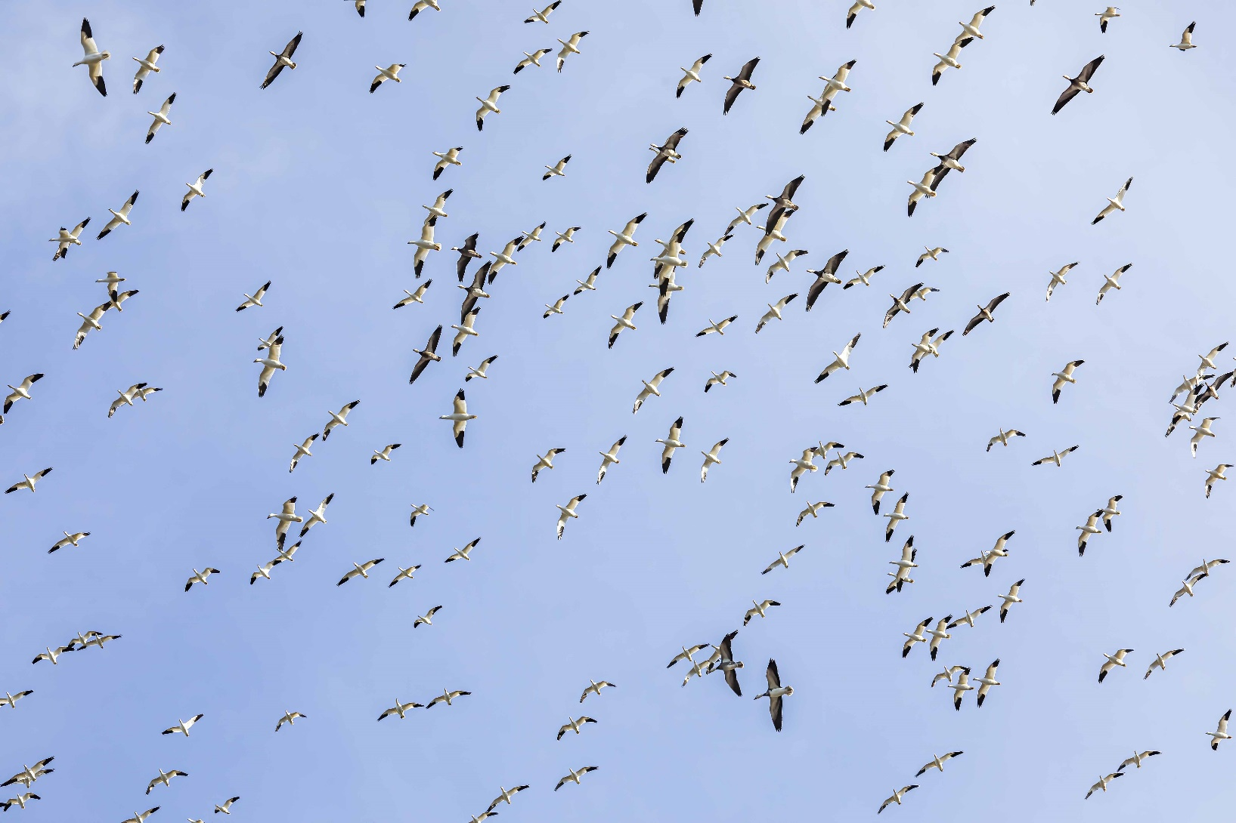
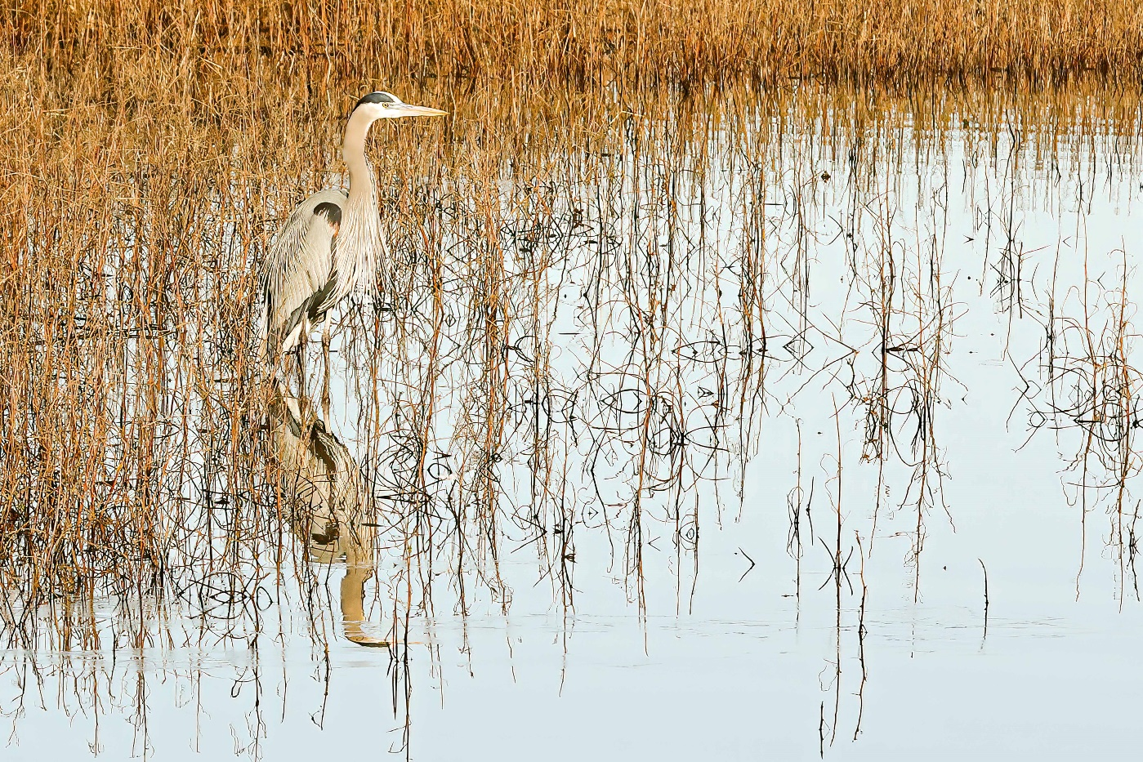
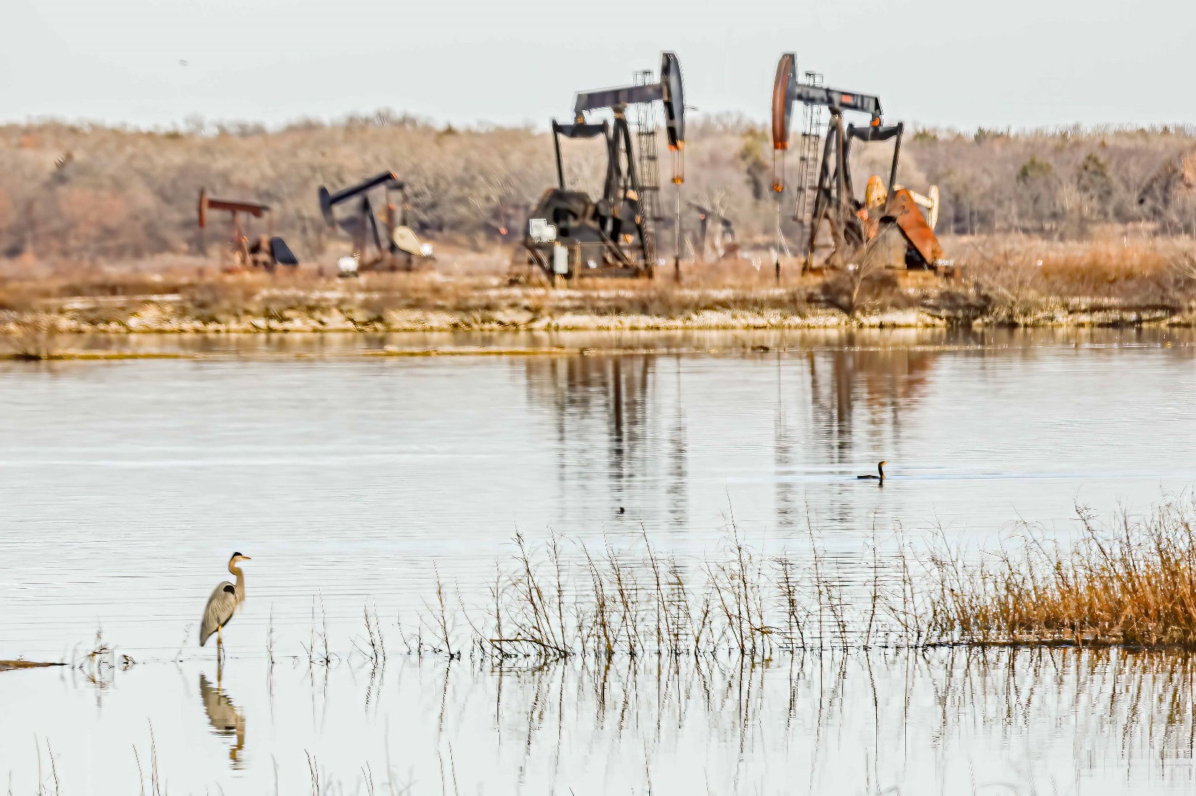

End of document

