Purpose
The purpose of this document is to identify points of interest for photographers. The document does not attempt to create an itenerary nor address logistical issues.

Trip Profile
Topic | Details
Trip Name | USA_Texas_Dallas_Trinity River Skyline Trail
Short Description | This is probably the best spot for a cityscape of the Dallas downtown skyline.
Web Site | https://www.dallascounty.org/departments/plandev/trails/maps/skyline.php
Contributor/email | Sam Lucas – SamHoustonLucas@Aol.com
Travel Time | Day trip
Date trip taken | January 2021
Points of Interest | Cityscape
Address for Mapping Software | Trinity River Skyline Trail  Or  100 Canada Dallas Texas or Gulden Drive
Restrictions / Safety Issues | Substantial safety measures should be taken. Be very aware of all individuals. Visiting in a group is highly recommended.
Entry Fee | None
Lodging Notes | Downtown Dallas has many hotels.
Dining Suggestions | There is a restaurant complex next to this park.

Special notes
ID | Note
1 | This is a very urban area and there is traffic at all hours. Substantial saftey measures should be taken.
2 | The best time is directly after heavy rain events. This will give you the opportunity to get a skyline shot with reflections from the river.
3 | There is a large parking lot and it is free.

Continued on following pages

Overview
This is one of the best locations to photograph the Dallas city skyline. It is located immediately adjacent to the Margaret Hunt Hill Bridge and overlooks the Trinity River basin.
Parking
After crossing the bridge, turn right on Gulden. In about 200 yards, you will approach the intersection of Canada and Gulden. Take an immediate hard right to enter the parking lot.
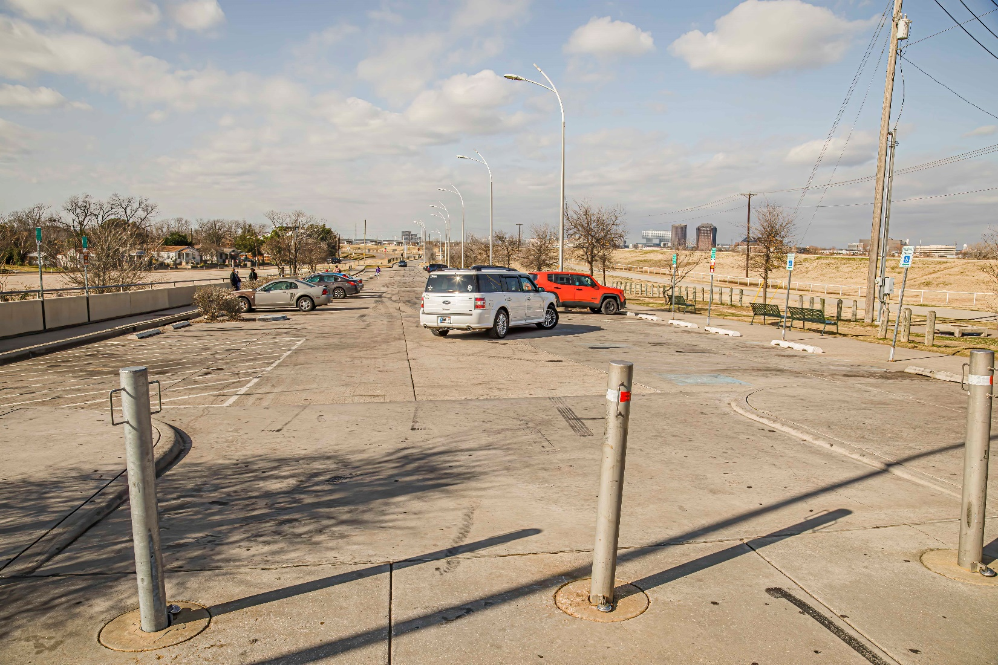

Photo Opportunity
.
There is a tall levee between the parking area and the river. This image wa taken at the top of the levee.
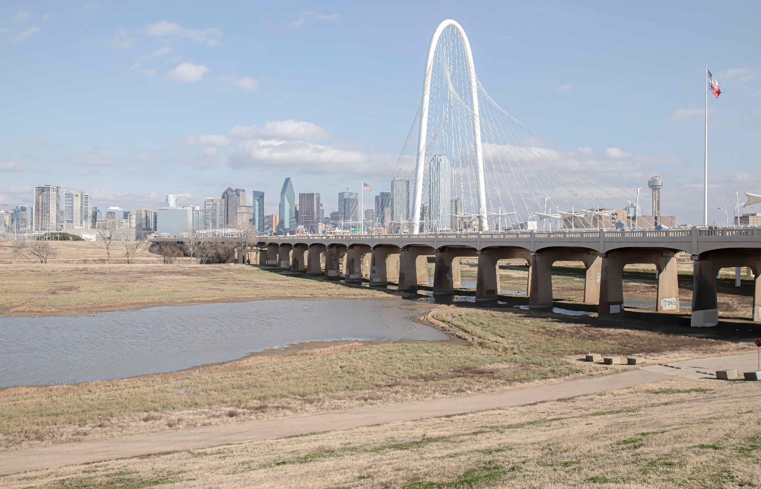

End of document

