Trip Profile
Topic | Details
Trip Name | USA_Colorado_Colorado Springs_Garden of the Gods
Short Description | This city park offers many nice landscape opportunities with easy access.
Web Site | https://www.gardenofgods.com/
Contributor/email | Sam Lucas / SamHoustonLucas@aol.com
Travel Time | From Dallas, about 11 hours by car
Date trip taken | July 2021
Points of Interest | Landscape
Address for Mapping Software | Garden of the Gods  North 30th Street  Colorado Springs, Colorado
Restrictions / Safety Issues | This is a city park but it is very large. Normal safety precautions should be followed.
Entry Fee | None
Lodging Suggestions | N/A
Dining Suggestions | N/A
Best Shooting Time of Day | Early morning
Primary GPS Coordinate | Not available

Overview
This is a large city park with excellent roads and parking lots providing easy access to many large rock formations. There is an excellent visitor center where tours via jeep, Segway can be purchased. The park is free and drivable with a normal car. There are also many hiking trails.
The park is very popular so I recommend early mornings and week days to avoid the crowds.

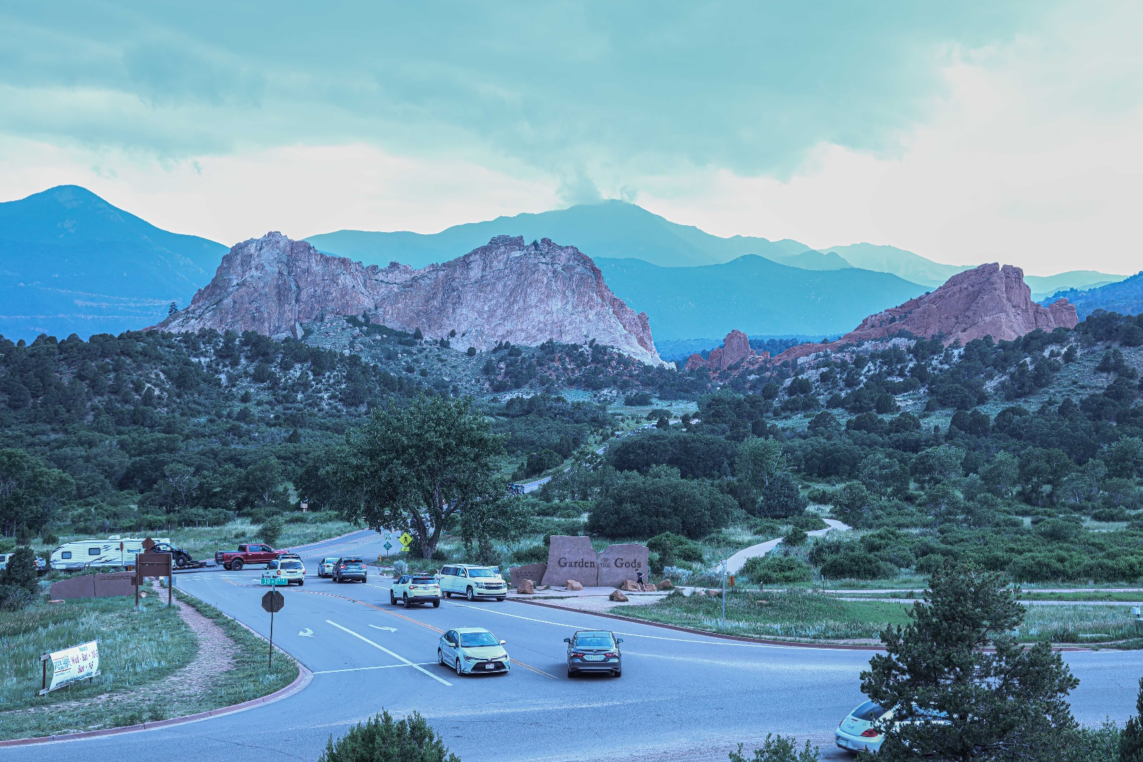
The image (above) was taken from the visitor center at the entrance to the park.

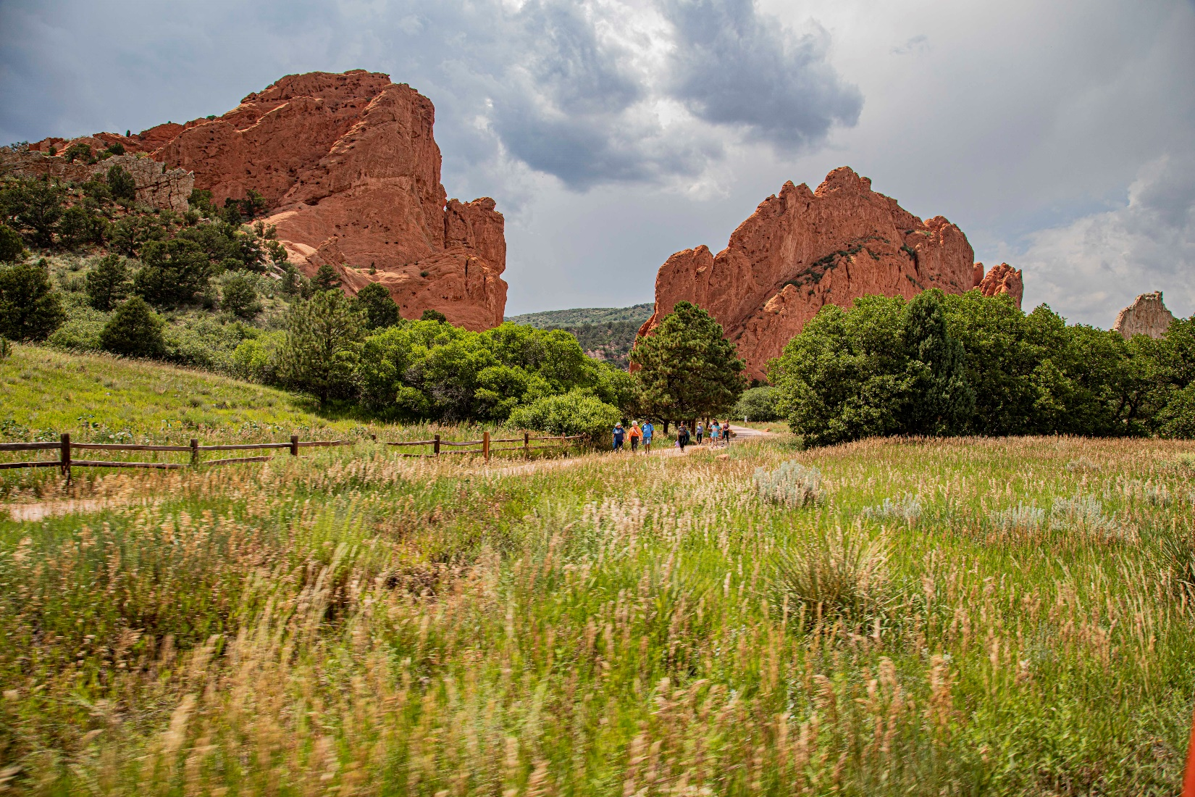
This is an example of the formations easily accessed

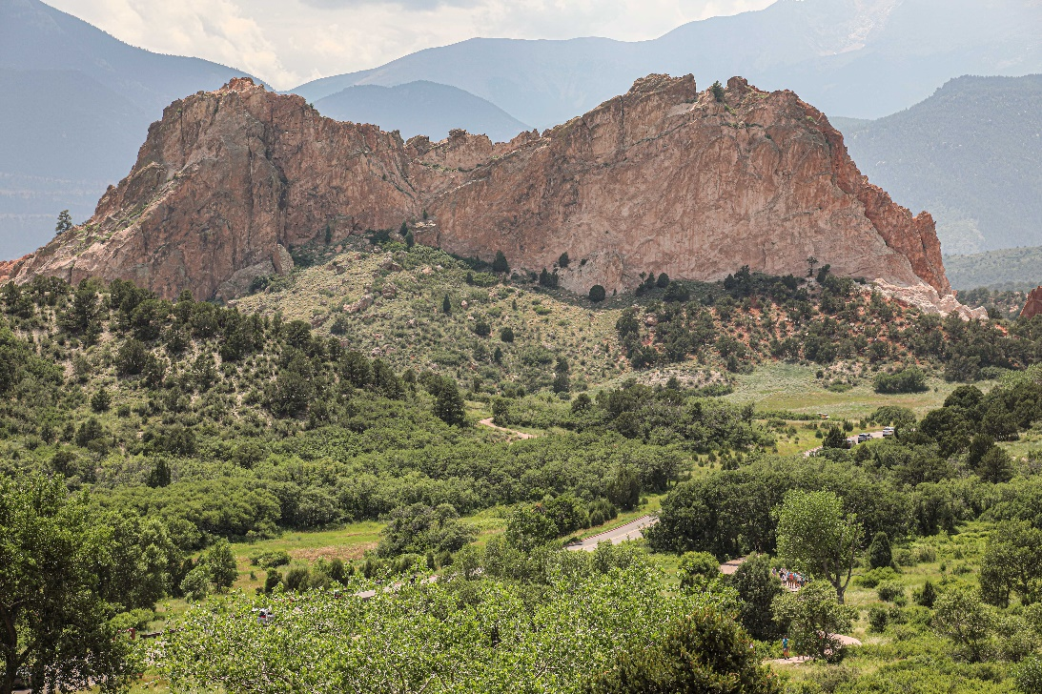

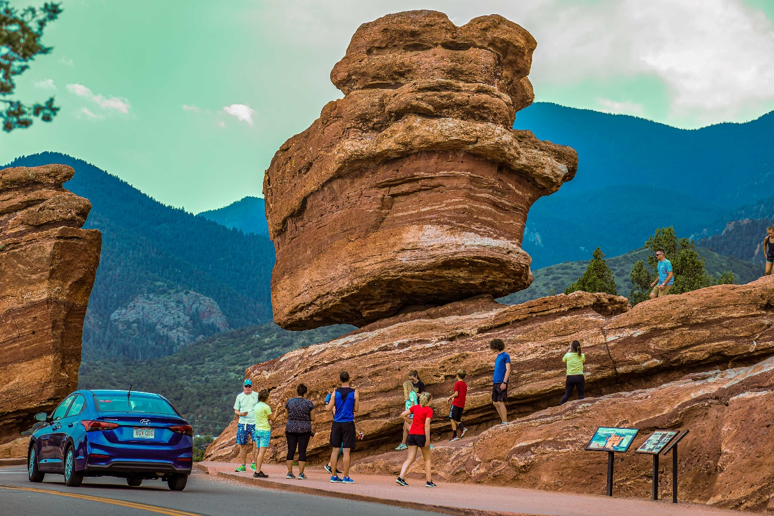

Here is a map from the web site

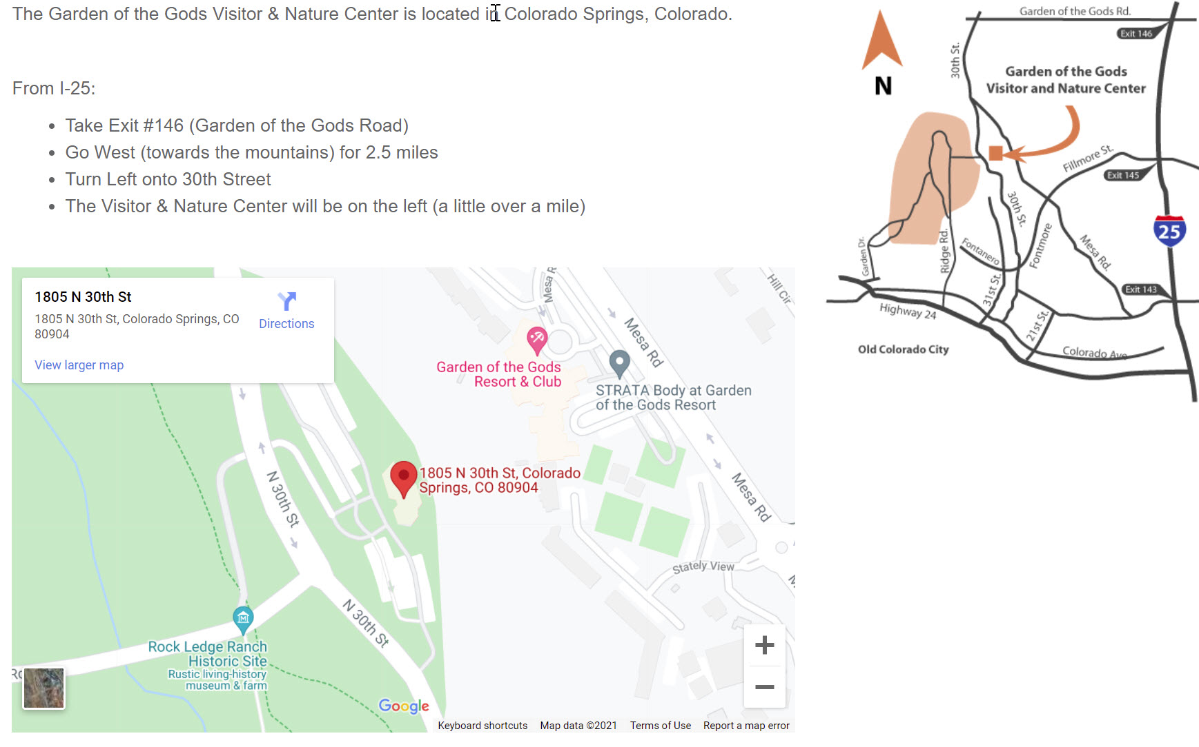

End of document

