Purpose
The purpose of this document is to identify points of interest for photographers. The document does not attempt to create an itenerary nor address logistical issues.
Trip Profile
Topic | Details
Trip Name | The Audubon’s Sanctuary at High Island
Short Description | This is good for birding and fantastic in April (Smith Oaks Sanctuary)
Website | https://houstonaudubon.org/sanctuaries/high-island/visitor.html  https://houstonaudubon.org/sanctuaries/high-island/rookery.html
Contributor/email | Sam Lucas SamHoustonLucas@aol.com
Travel Time | From Dallas, plan on 5.5 hours of drive time  From Houston, plan on 2.0 hours
Date trip taken | 2021
Points of Interest | Birds – Many waterfowl type birds and migrating birds
Address for Mapping Software | 2205 Old Mexico Rd, High Island, TX 77623
Restrictions / Safety Issues | No hunting. This is a remote rural area.
Entry Fee | Day patch is $8.00. Patch for full year of access is $30.00.
Lodging Notes | There is one motel in High Island. Winnie and Galveston are nearby.
Dining Notes | Very limited.
Best shooting time of day | Early morning and sunset.
Primary GPS Coordinate | This is optional

Special notes
ID | Note
1 | Mosquitoes are always a problem. You definitely need repellant.
2 | This site is owned by the Houston Audubon Society. Explore their web site for a full description of the site. Some rules and policies are in Appendix A (below)
3 | There are hundreds of alligators. Be very careful.
4 | There are multiple areas to explore.

Overview
The four sanctuaries at High Island (Boy Scout Woods, Smith Oaks, Eubanks Woods, and Gast Red Bay) are open 365 days a year, dawn to dusk. At Smith Oaks the gate at Old Mexico Rd is open dawn to dusk March 15-May 15 and on weekends in the fall: September 15-October 15. The Winnie Street entrance at Smith Oaks is open 365 days a year, dawn to dusk.

Stop 1 – Smith Oaks

Normally, this island is barren and of little interest. However, in April it ‘blossoms’ as a rookery for many water fowl.

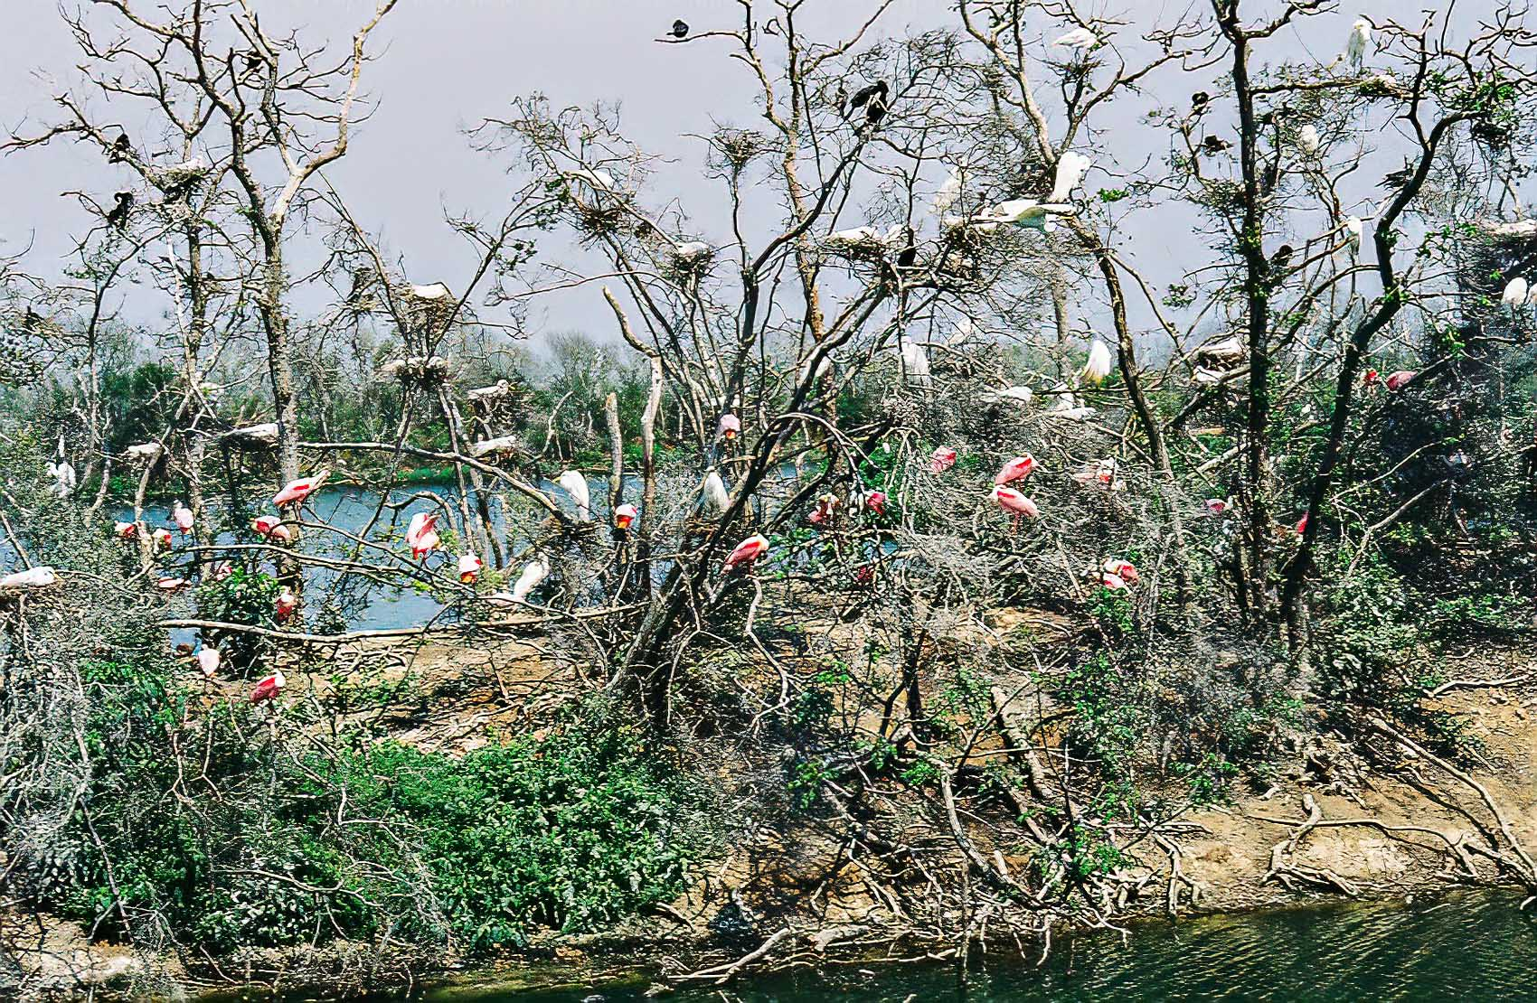
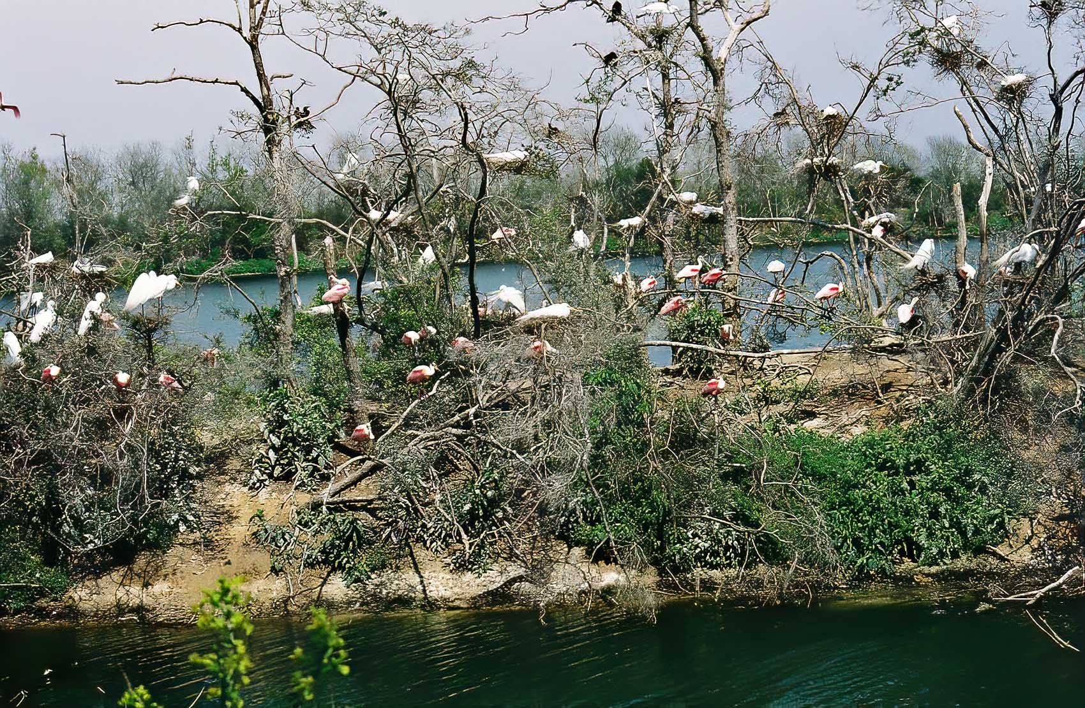
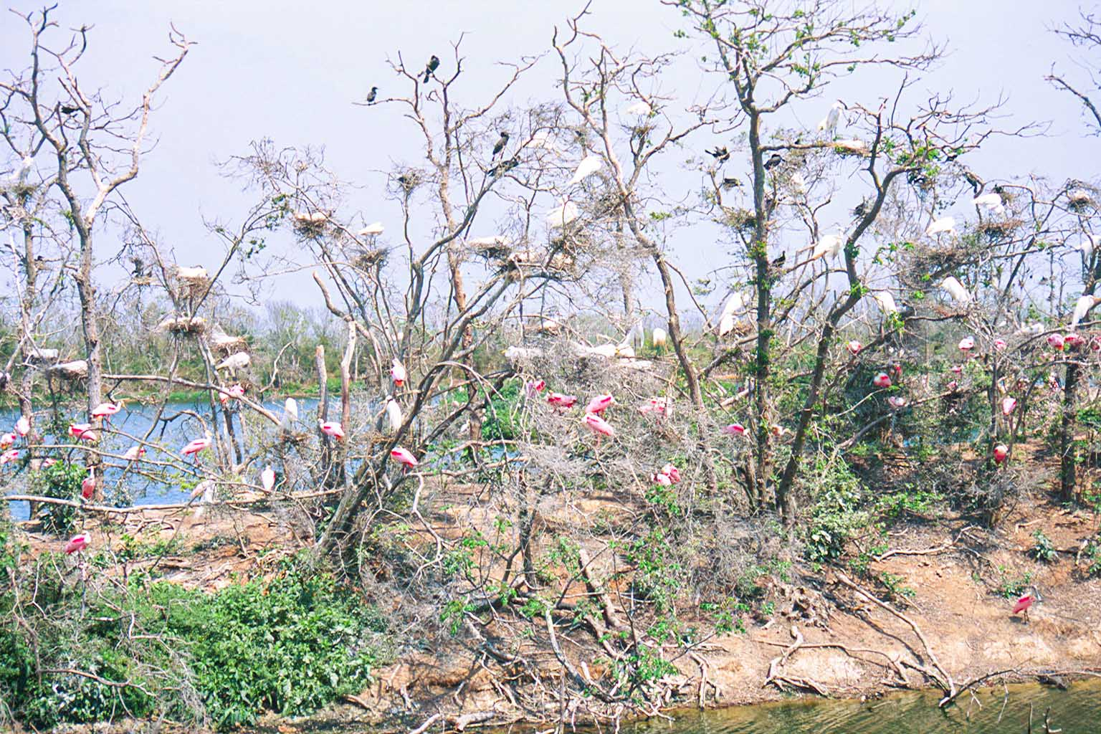
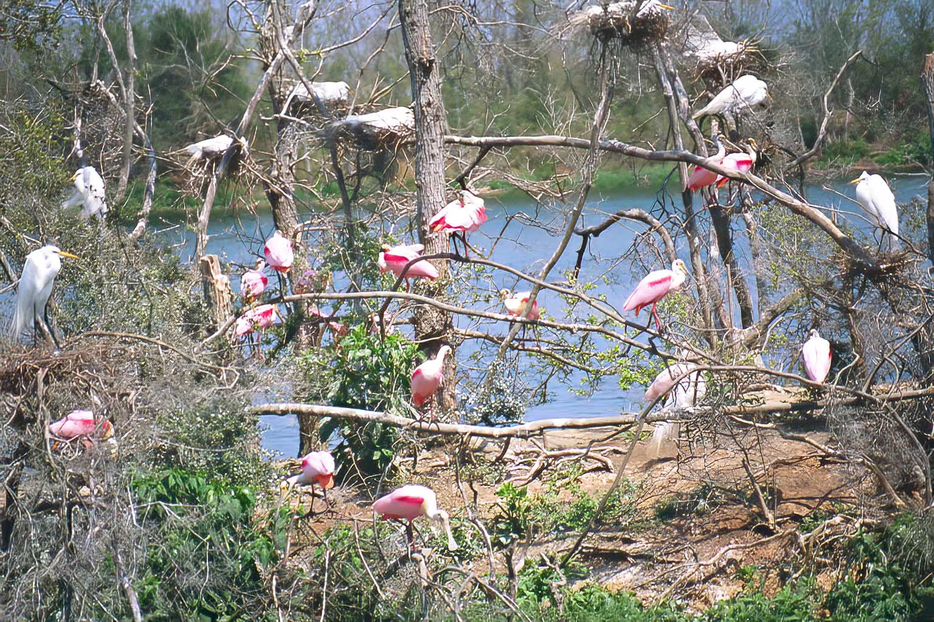

Appendix A – Policies and rules

The following were copies from the web site.

POLICIES
Because this is a wildlife sanctuary, we ask you to observe the following rules.
- Respect all wildlife. You are the visitor. This is their home.
- Respect the peace and be considerate of other sanctuary visitors.
- No harming or collecting or introduction of plants or animals.
- Leave no waste.
- Stay on marked trails. Walking only. No bicycles.
- Do not obstruct trails.
Please be considerate of other visitors. Do not block trails with tripods, chairs, ladders, baggage, etc.
- No drone photography.
- Use of laser pointers is prohibited at all Houston Audubon sanctuaries.
No pishing or use of playback devices unless special permission is obtained.
- Firearms are not permitted on the grounds.
- No smoking or alcohol consumption.
- No dogs or other domestic animals.
Contact Pete Deichmann, Sanctuaries Manager, at pdeichmann@houstonaudubon.org with any questions.

Appendix A – Maps

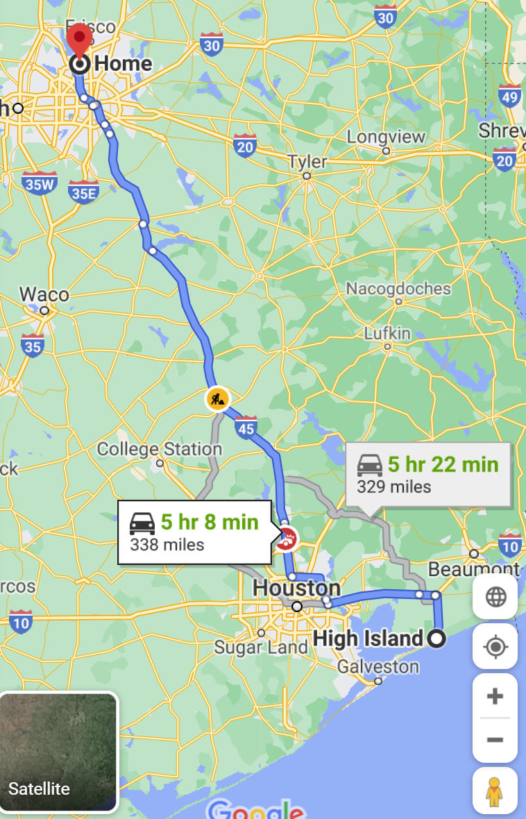

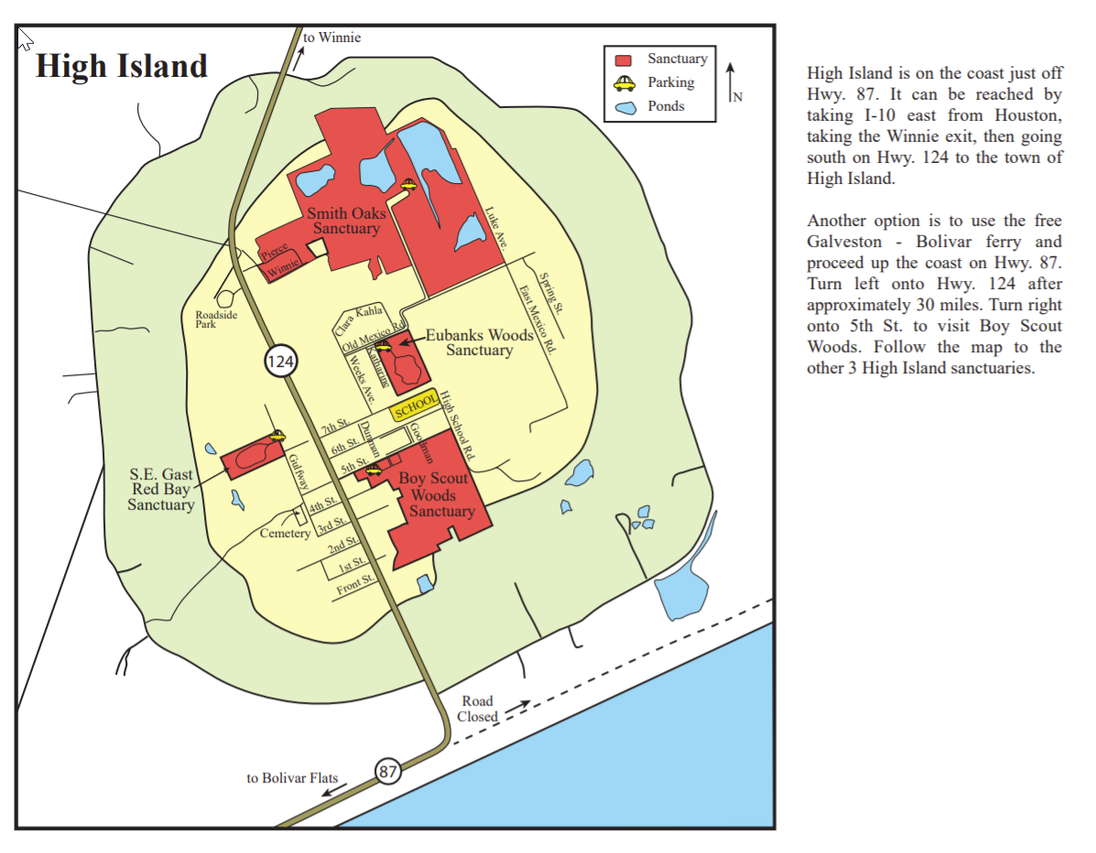

End of document

