PhotoPills Demo

Intro
PhotoPills is huge! When I first downloaded and opened it, I was lost. It was just too complicated and I didn’t know where to start. So, here are some tips:
Don’t try to learn it all at once. Want to know what time the sun sets? Look that up. Add a different date. Add a different location. Check for the next full moon. See when the Milky Way’ core will come up in different places on different dates.
When you feel more comfortable check out the planner. Plan a hypothetical trip to somewhere you always wanted to go.
Use the videos and user guide – they are invaluable. The best videos I have found are the PhotoPills Friday (episodes 1-12).on YouTube

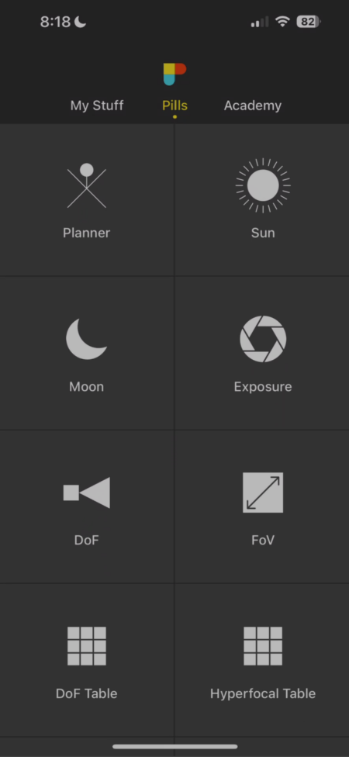
The interface
There are three primary sections – My Stuff, Pills, and Academy.

My Stuff
I strongly suggest going to settings. You will find that under My Stuff. Set units, exposure increments, your camera, etc. Access your saved plans, and points of interest. Back up everything to a file. Submit your images for Awards. (There is a monthly $100 prize.) View other PhotoPillers’ images. The team does pay attention to feedback I had asked them if they could tie Google Street View into the planner, so you could see what the view from your position pin looked like. They said they would very much like to do that. But it would have to be a subscription model because everytime they made a call to street view they would have to pay Google.

Academy
How-to articles and Videos. Warning, they are recorded by Raphael Pons. He knows his stuff but has a very heavy accent and is hard to understand.
- You can buy t-shirts and provide free advertising for the developers.
- Provide feedback. I can testify that they do listen and respond. I asked them if they could provide a way to bring in the map interface. As it turns out, you can send a plan to Google Maps and use Street View from there.
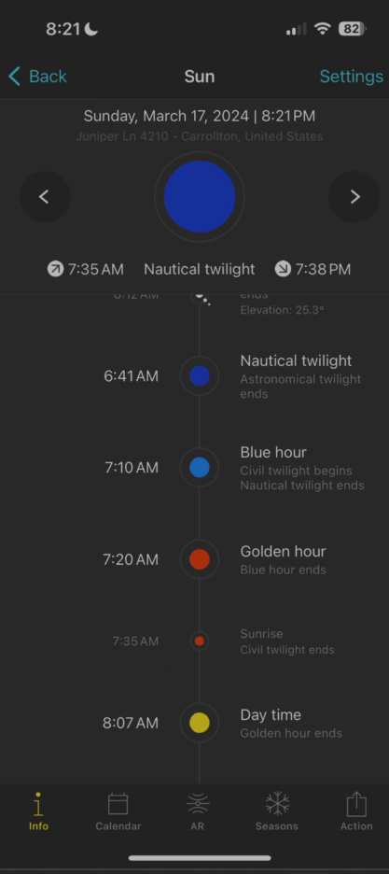
Once you know your way around PhotoPills you probably won’t spend any time in the Academy tab at all.

Pills
The pills form the building blocks of PhotoPills. This is where you can go for quick lookups – sunrise, reciprocal exposures, etc. It’s also the entry point for the planner. To be honest, I use some of the pills a lot – others not at all. Let’s go look at some of the ones I use a lot.

Sun
Sunrise, sunset, golden hour, etc
Graph on the bottom to scroll through the day
Show how that changes the Azimuth, Time to set, etc.
Show shadow ratio – ratio of the length of the shadows to the height of objects.
Bottom Bar
Change the location
Change the date
Augmented Reality use on-site to see where the sun will be at a given time of day.

Moon
The Moon pill shares a lot with the Sun pill – it retains the location and date.
Moon phases on the top center in the iPhone app. Click on the Calendar to see the moon phase for all days.
Asimuth, elevation, distance time to set, rise and light at the bottom, or on the right in the iPad app. Again, everything changes as you scroll the graph
Milky way, sunrise, sunset, moonrise, moonset times on the left

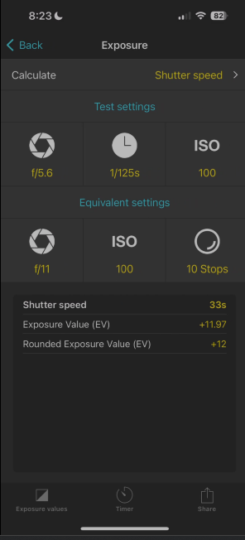
Exposure
Say you want to take a long exposure with a 10 stop ND filter.
- You are going to shoot at f/4.0 and ISO 200. Take a test shot and find that 1/125 second is good. Set those up in the test settings
- Set the Equivalent settings to the desired Aperture and ISO
- Set the filter to 10 stops
- Read the new shutter speed at the bottom

Hyperfocal Table
- Simple way to find the hyperfocal distance for your particular camera at any f/stop and focal length
- Or you can use Classic DoF and enter the focal length, aperture and subject distance, and it’ll give you
- Hyoerefocal distance
- Near limit
- Far limit
- DoF in front, back, and overall
- Or you can use the Classic DOF, enter all that stuff and go to augmented reality, and it will show you where your near point, and hyperfocal distance is.
(Or you an eyeball it like I do.)

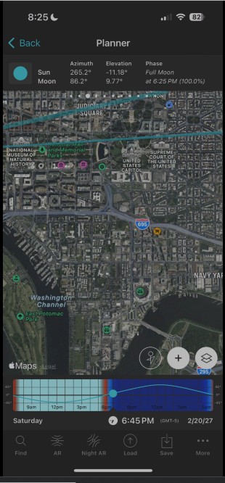
The Planner
The Planner is where it all comes together. It works on layers that you can turn on and off. You can:
- Set date and location
- Use street or satellite maps, Apple or Google
- See the path of the sun and moon throughout the day and night
- Pinpoint your shooting location and subject
- It will tell you how far you are from your subject
- It will tell you the elevation difference and distance between you and the subject
- How big the moon appears over your subject
- See the Milky Way visibility and core location
- Set it to show daylight, nighttime, twilight, golden hour, etc.
There are four main sections of the planner.
- Top bar
- Map
- Timeline
- Bottom bar
The top bar is scrollable – scroll left and show panels. You can activate the panels on the top bar to make the layers active on the map. Turn on and off sun, moon, milky way.
Map – drag it around with your finger. You may see lines and dots on the map that indicate the sunrise and set position, moonrise and set position, the azimuth of each, the milky way, etc. You might see a pins indicating your subject position. As you work turn off the ones you don’t need for simplicity. The three buttons on the bottom of the map give you map tools. I don’t use any of them but the one on the right. Which is the layers tool.
Click the one on the right. There are two modes – camera and drone. I only use camera, but Drone mode shows you the frame captured depending on the altitude of your drone.
Under that is where you can change your map type. PhotoPills will utilize Google or Apple maps, and you can switch between satellite, terrain, street, or hybrid street/satellite, which is what I prefer.
Under the map type is a shortcut to turning the layers on and off. I usually go here rather than the top bar unless I want to see some of the information on the top bar.
The colors on the timeline bar indicate time of day. The light blue is daytime, the orange is golden hour, the medium blues are blue hour and twilight, and the darkest blue is nighttime. You can put your finger on the dot and slide it left or right to go back and forward in time.
The bottom bar is where you change the location and date, go to augmented reality, etc. One thing people find confusing is that you would think you would use find to go to a location but that is under load. Find is a very powerful tool, which we will go into later.
Let’s look at the sun and moon layers.
If you turn on the sun later, you can see a yellow line and orange line have been added radiating out from the red position pin. The yellow line shows the azimuth of the sunrise, and the orange line shows the azimuth of the sunset. As I scroll the timeline, a thin yellow line shows the azimuth of the sun throughout the day, and it changes to an orange line as the sun lowers towards sunset. So you always know where the sun will be in relationship to your subject.
The moon layer works the same way, except the lines are blue.

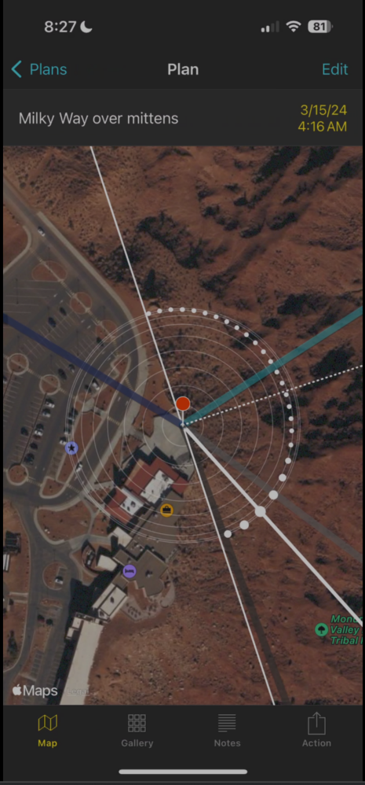
So let’s plan a shoot:
I have seen some beautiful shots of Monument Valley under the Milky Way I want to go in the spring, but late enough that I’m not likely to deal with snow – Maybe April – June.
- Look for the new moon, or even a crescent moon in April. I would sort of like to shoot under a crescent moon, and looking at April 4, it’s a crescent, but it’s just coming up in the east right between the mittens. That wouldn’t work well. So I’ll plan to shoot during the new moon on April 8th and get my landscape during blue hour.
- I want to shoot from The View Hotel’s observation deck toward the Mitten Buttes. Load The Mittens. That puts the red pin between the mittens, like we were going to shoot from there, but we aren’t. So bring up the black pin by clicking on the pins layer until it’s turned on and move it to the location of the red pin.
- Load the View Hotel, to set red pin
- Show the Milky Way layer. The light grey line is where the core is first visible. The dark grey line is where it goes below the horizon.
- Scroll through the night to position the Milky Way where you want it. That would be about 3:30-4:00 AM.
You can save the plan to get back to it later. You will find it in My Stuff.
That is a very simple but effective use of the planner. There is so much more to it, and I strongly suggest going to YouTube and watching PhotoPills Friday.

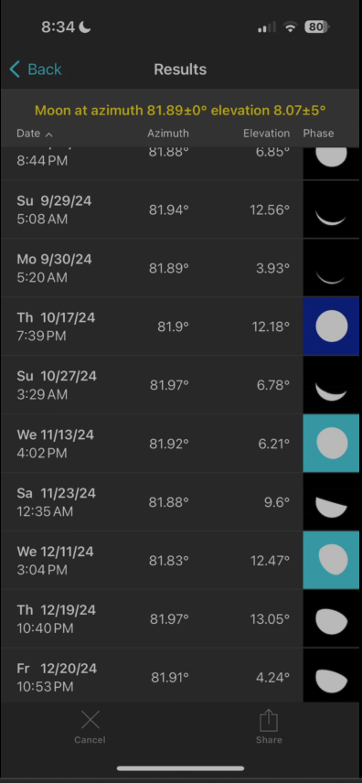
Find
I’m sure you have seen those shots where the moon is balanced on the top of the Statue of Liberty or the sun is setting at the end of 42nd street in Manhattan (Matterhenge). Believe me, they weren’t a lucky coincidence. They were planned using a tool like the Photographer’s Ephemerous or PhotoPills. So how do they know where to be and when for those shots? Find!
I think an image of the Washington Monument at dusk with the moon beside it would be really nice.
- Go to Google Maps and find the Washington Monument
- Use street view to find a good place to stand and place red pin
- Go to the monument and place black pin.
- Find out how tall the monument is 554 feet 7 inches. Call it 555 for our purposes
- Find the difference in height from our shooting place. The monument is 23 feet higher than the red pin. (Difference in height always uses ground level, not the object there.)
- Add 255 to 23, and if we want the moon a little to the left of the point – that’s the elevation we would want. But I’d like it a little higher, say 20 more feet. So 255+45=300.
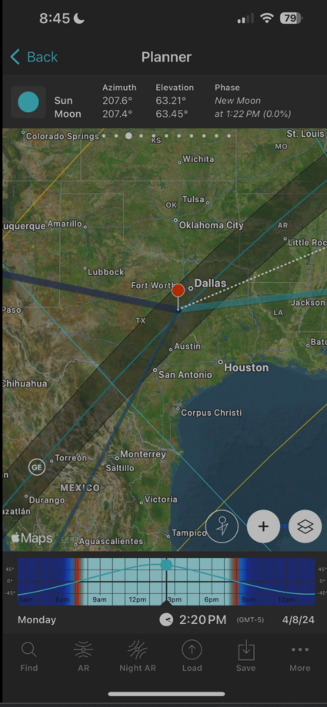
- Find moon at azimuth and elevation and set the azimuth error at 0 and the elevation error to 5օ
- Hit the magnifying glass and pick a twilight time when the moon is full and a bit higher than the monument.

Eclipse
Eclipse will let you find any full or partial eclipse anywhere in the world at any date.
- Turn on Eclipse layer
- Show April 8, 2024
- Scroll out to show the path
- Place pin at your house and see the times for the eclipse and totality in the top bar
- Move pin to the center line and show the length of totality
- Scroll timeline and show virtual eclipse

