Trip Profile
Topic | Details
Trip Name | USA_Colorado_Colorado Springs_Cheyenne Mountain Zoo
Short Description | This is a very good zoo sitting on top of a mountain.
Website | https://www.cmzoo.org/
Contributor/email | Sam Lucas / SamHoustonLucas@aol.com
Travel Time | Drive time is 11 hours from Dallas
Date trip taken | July 2021
Points of Interest | Wildlife, landscapes
Address for Mapping Software | 4250 Cheyenne Mountain Zoo Road
Restrictions / Safety Issues | Very Safe
Entry Fee | Adult varies from 19.00 to 35.00 (see Appendix A - pricing table below)
Lodging Notes | This is in a large city, so many hotels, motels are available.
Dining Notes | This is in a large city, so many restaurants are available.
Best shooting time of day | Mornings
Primary GPS Coordinate

Currently, admittance is being tightly controled due to the pandemic. Buying tickets online prior to arrival is required at this point in time.

Overview

This zoo sits on top of a mountain and is very hilly. There is a tram available. So, to do your tour, consider taking the tram to the top and walking down. The African exhibits are excellent and good images of giraffes and elephants are easy to take. There are many opportunities to interact with the animals (giraffe’s, elephants, birds, goats).

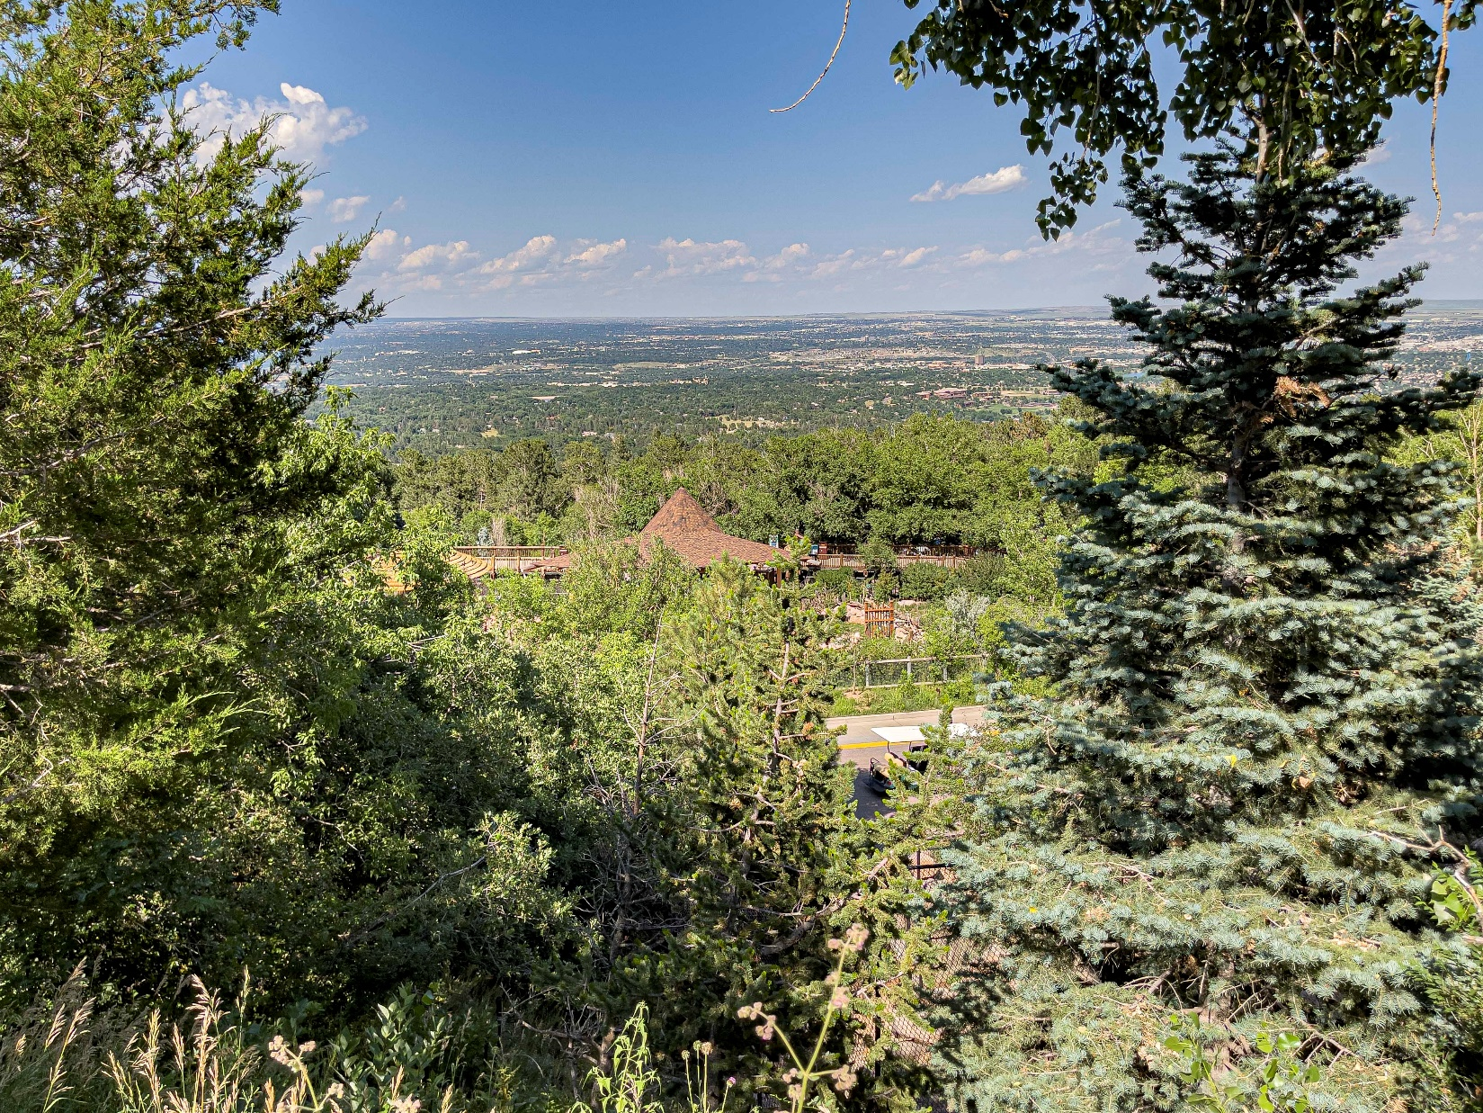
This is a view from the top of the zoo.

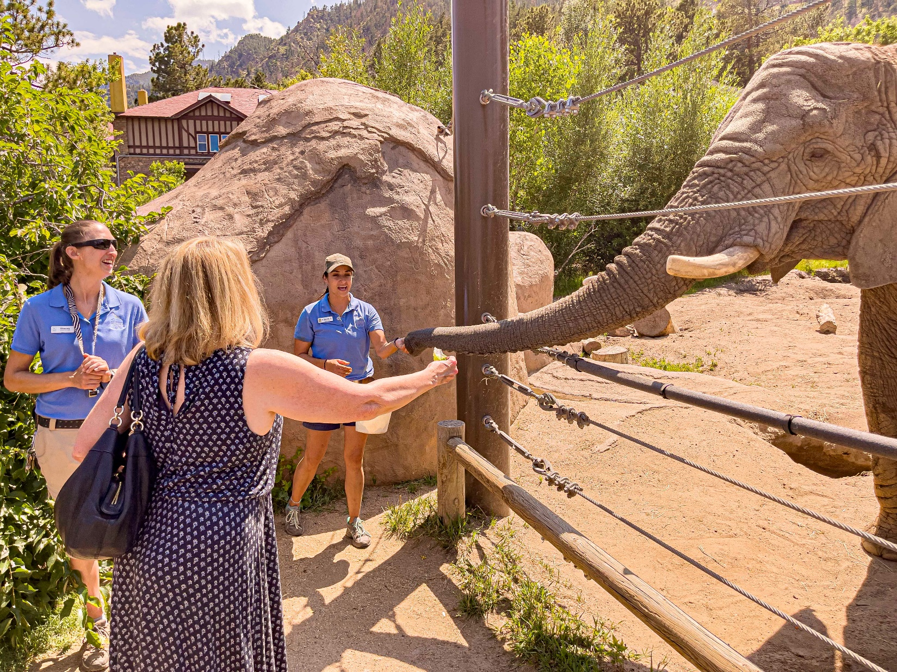
This shows the elephant feeding stop. It is not very easy to position yourself for a good photo. The food is purchased right by the feeding station. This elephant is named Lucky.

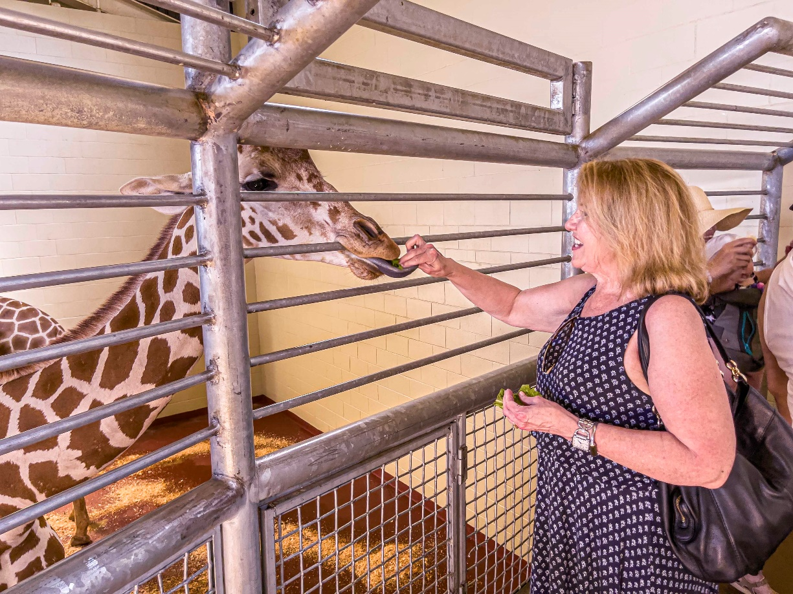

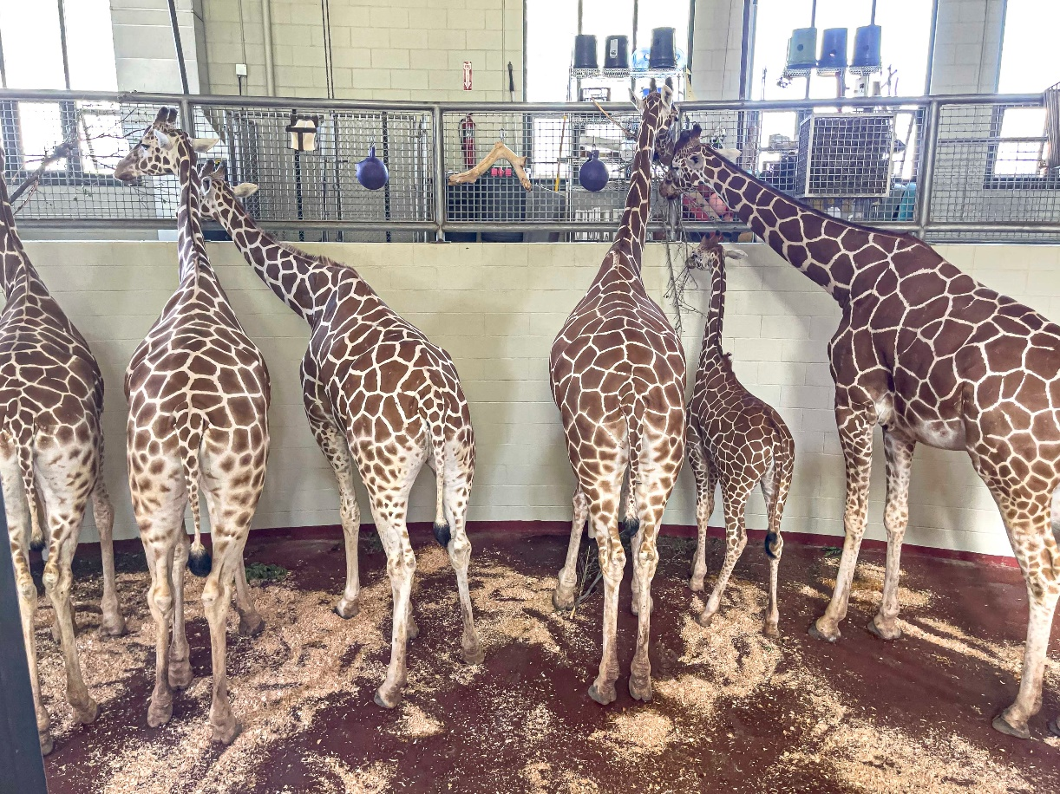

There about 15 giraffes at a wide range of ages. The outdoor exhibit is very large, but I did not get a picture of it. Feeding can take place inside their building.

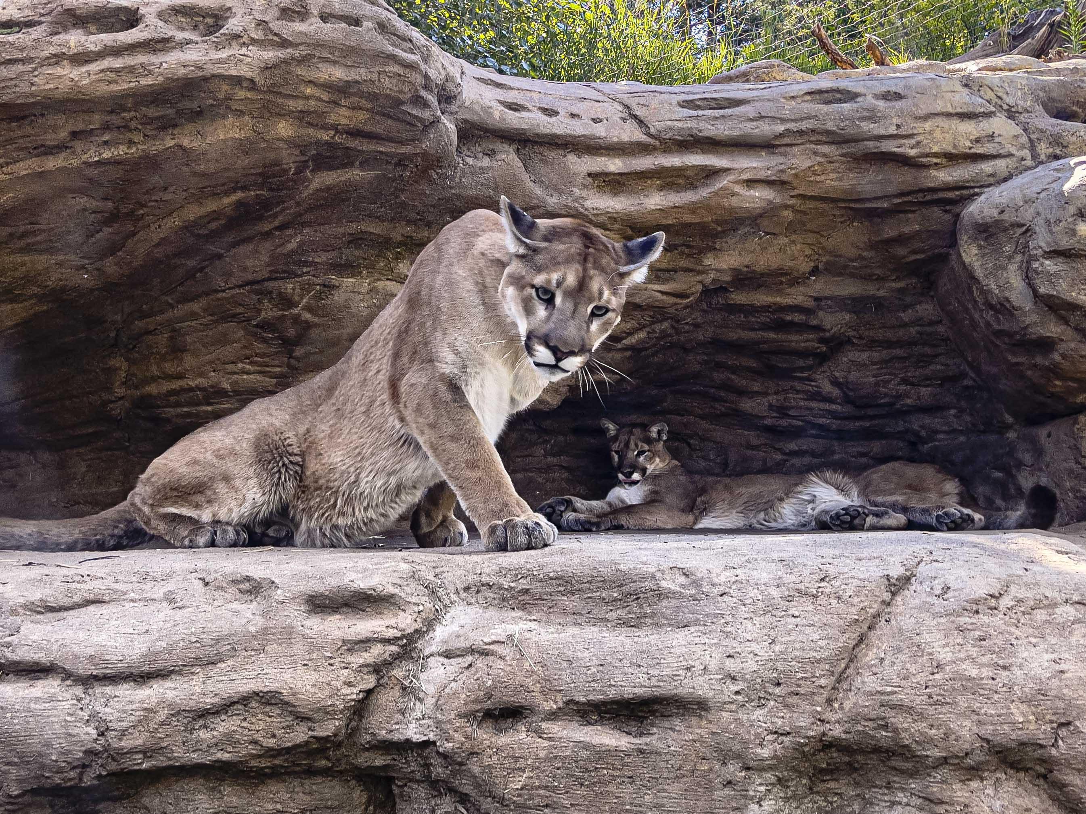
The cougars were posing for us.
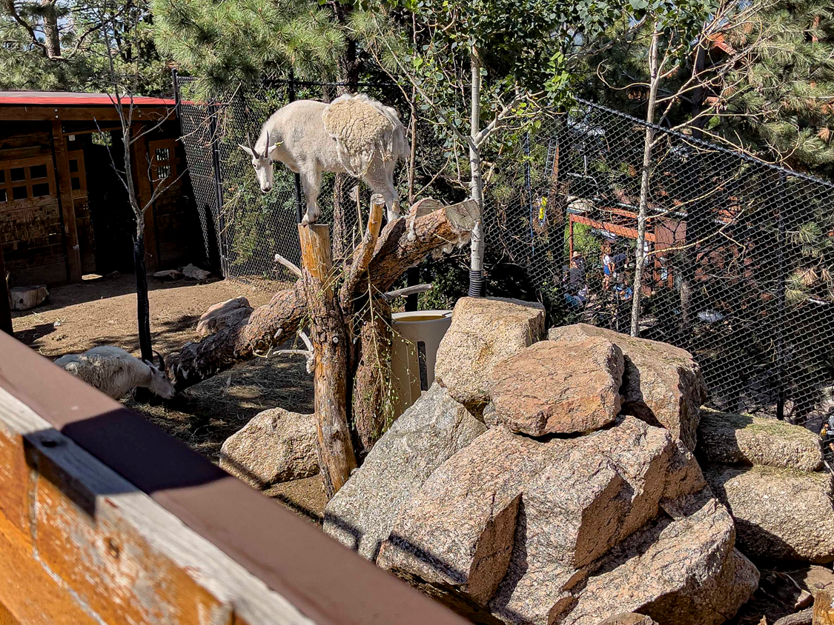
Mountain Goat

The bird house contains parakeets and cockatiels that are loose and sitting on high branches. The kids buy little seed sticks to feed to the birds.

\

Appendix A – Sample Pricing table
This is as of July 2021 and will vary as the years go by.

https://www.cmzoo.org/wp-content/uploads/2021_CMZPricingCalendar_07-07-21.pdf

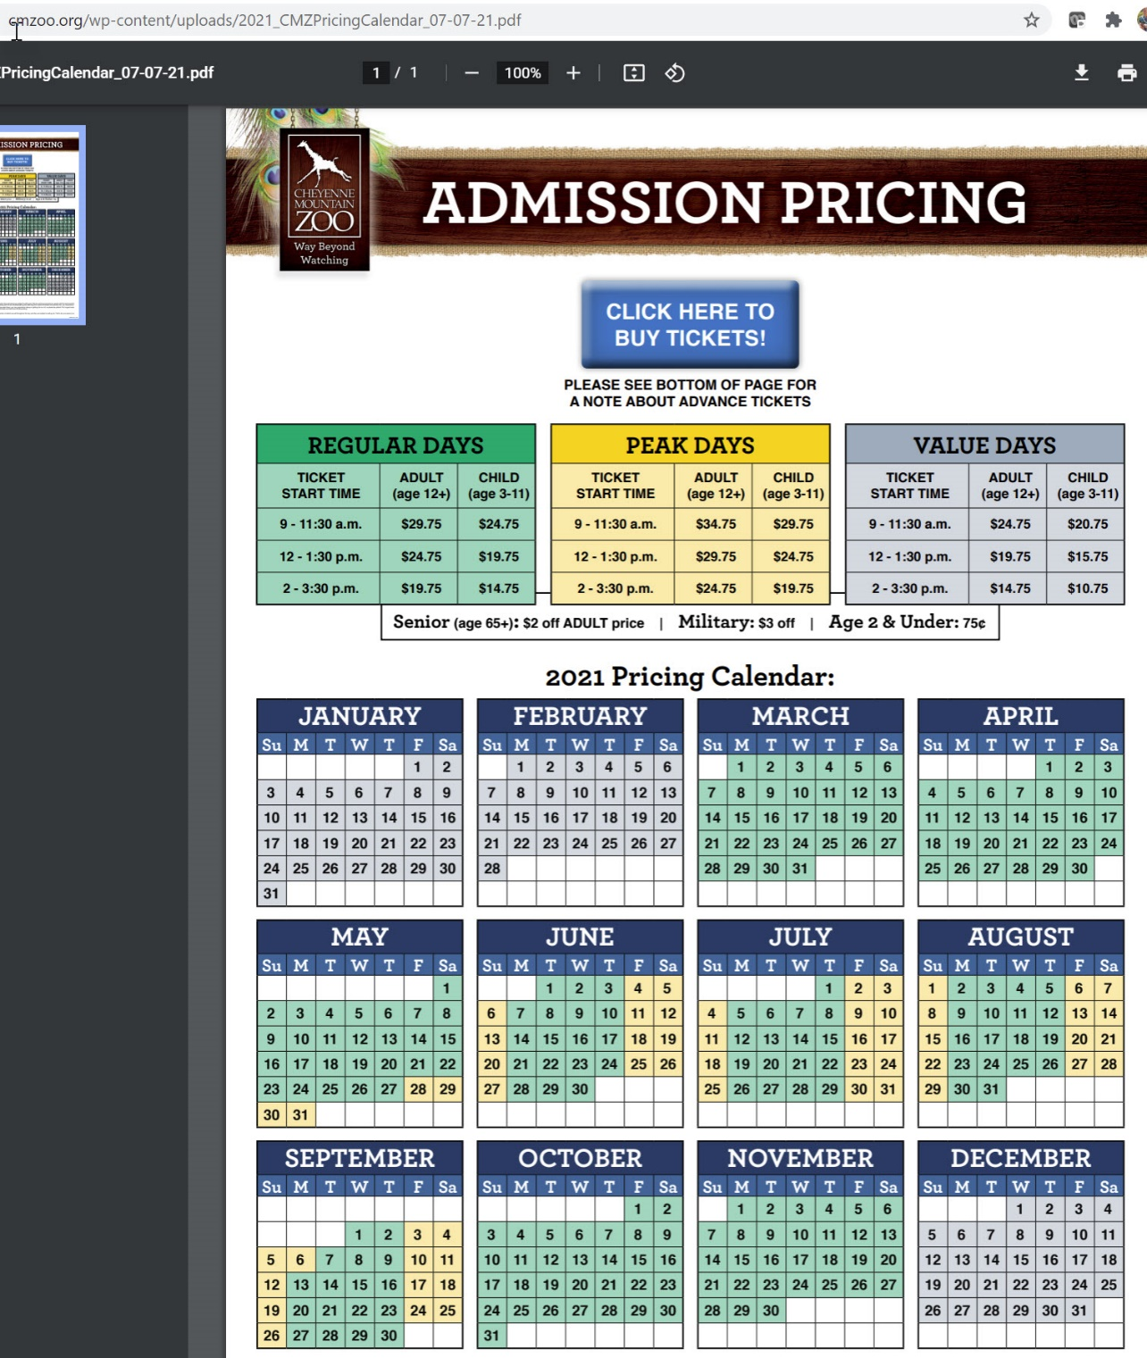

End of document

