Purpose
The purpose of this document is to identify points of interest for photographers. The document does not attempt to create an itenerary nor address logistical issues.

Trip Profile
Topic | Details
Trip Name | USA_Texas_Weatherford_Clark Gardens
Short Description | A lovely garden west of Weatherford, Texas,. It is about the size of the Arboretum in Dallas but layed out with interesting pathways besides pools and small waterfalls.
Web Site | https://www.clarkgardens.org/ phone – 940-682-4856
Contributor/email | Jay Hoppenstein EMAIL _Navigato@aol.com
Travel Time | From Dallas, about 1.5 hour drive
Date trip taken | November 12, 2020
Points of Interest | The ponds and stream are delightful. Small bridges allow easy crossing. Some of the ponds have ducks swimming who are accustomed to human traffic and expect a food treat which can be purchased at the office.  There is also a G scale railroad train and a waterfall.
Lodging Suggestions | Clark Gardens offers a ‘Retreat’ house that can accommodate 1 to 10 peole.
Dining Suggestions | N/A

Special notes
ID | Note
1 | Address for mapping software:  567 Maddux Road  Weatherford, Texas 76088
2 | The entry fee is $9 adults, $7 seniors & $5 children; free admission for members of the Dallas Arboretum.

Continued on following pages

Overview
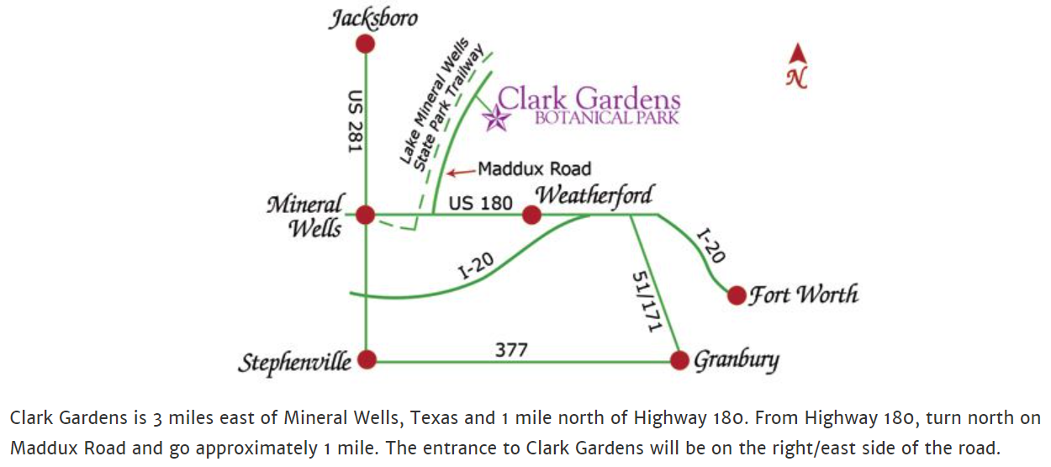
The property is a long rectangle with flat paved pathways meandering through the grounds. Walks take you past many hundreds of plants, most of which would be blooming in the spring. Our visit was in November and many of the rose bushes were still in bloom but at the end of the season.

Trip Narrative

Hal and Judy Sommer picked me and my wife, Carole Ann, up about 0900. On the road we soon passed through Ft. Worth and Weatherford. Our GPS accurately led us to the Clark Gardens. There were only a couple of cars in the parking area.
The lady in the office was very nice and she suggested a route to take to investigate most of the park. We each took a map and set out together, stopping frequently to photograph the remaining flowers in bloom. We knew that we were at the end of the flower blooming season so that we were not disappointed. There was some fall color in the trees.
The pathways wound around revealing ponds, fountains and small waterfalls. Rarely did we encounter any other visitors. We enjoyed the gardens for about 1.5 hours and then left to drive through Mineral Wells.
The old Baker Hotel, once a majestic place that people came to take the mineral rich water baths for promised health improvement. Now the hotel is under renovation and cannot be toured. We drove through some of the town’s center and residential area. We stopped at a pizza restaurant which was empty of customer for a nice lunch before turning east and returning to Dallas.

Images from Clark Gardens
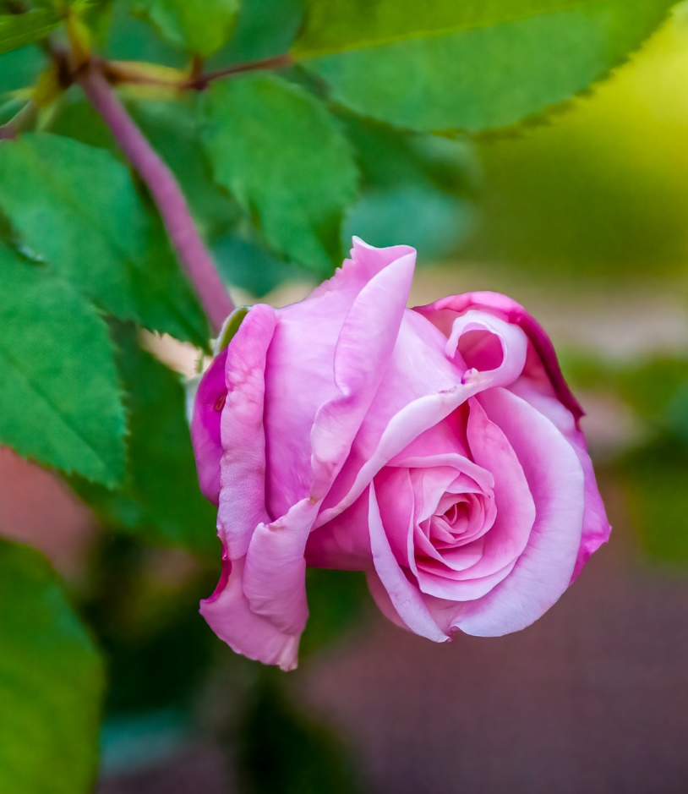

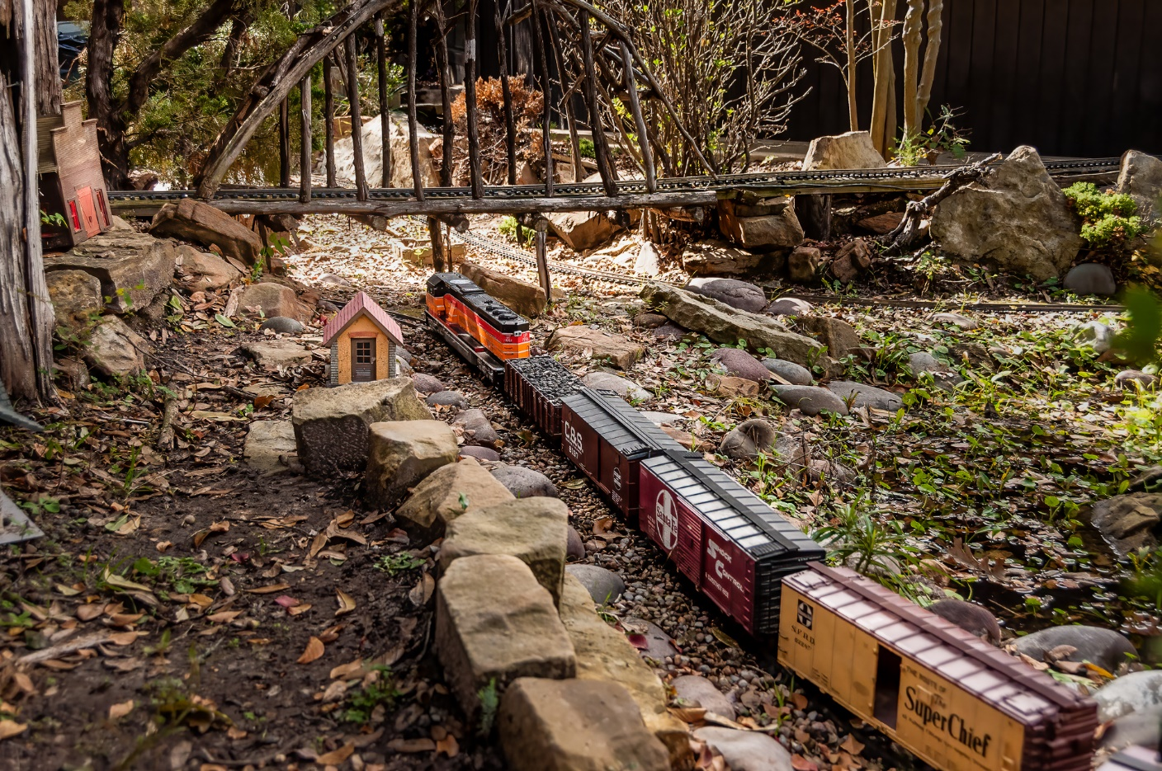
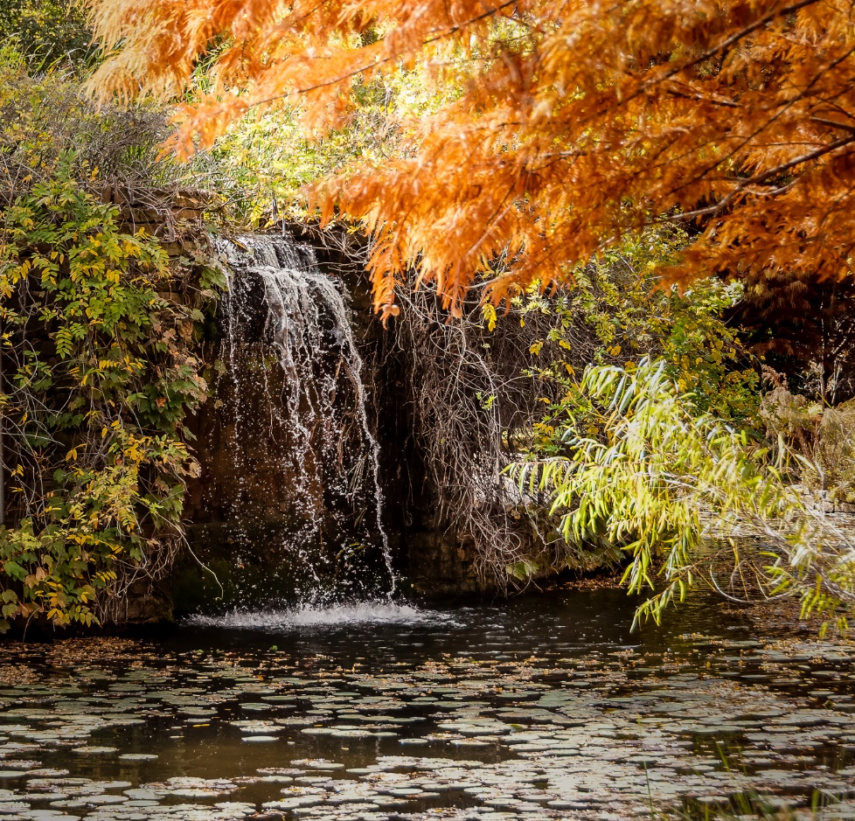

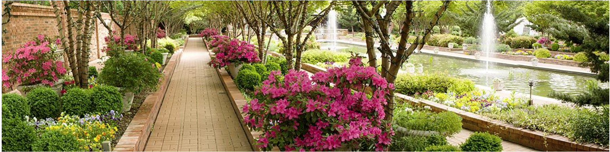

End of document

