Purpose
The purpose of this document is to identify points of interest for photographers. The document does not attempt to create an itenerary nor address logistical issues.

Trip Profile
Topic | Details
Trip Name | USA_Texas_Flower Mound_Riverwalk Fountain
Short Description | This is a large waterfall/fountain next to a premium apartment complex
Web Site | https://www.riverwalkflowermound.com/the-promenade
Contributor/email | Sam Lucas SamHoustonLucas@aol.com
Travel Time | From Dallas – 45 minutes
Date trip taken | December 1, 2020
Points of Interest | Waterfall/fountain,
Address for Mapping software | 4100 Riverwalk, Flower Mound, Texas
Restrictions / Safety Issues | This is a very safe area. It is in the middle of a group of high end apartment complexes.
Entry Fee | None
Lodging Notes | Flower Mound has many hotels/motels
Dining Notes | Flower Mound has many restuarants

Special notes
ID | Note
1
2
3

Continued on following pages

Overview

The fountain/waterfall is very wide and there is a small lake behind it. Parking is very easy and does not have a fee. Sometimes (winter?) the fountain is turned off.

Trip Narrative
This is an easy fountain shot. Parking is very close to a nice viewing pad. It is also very easy to keep pedistrians out of the image.

This is what the fountain looks like when it is turned on | 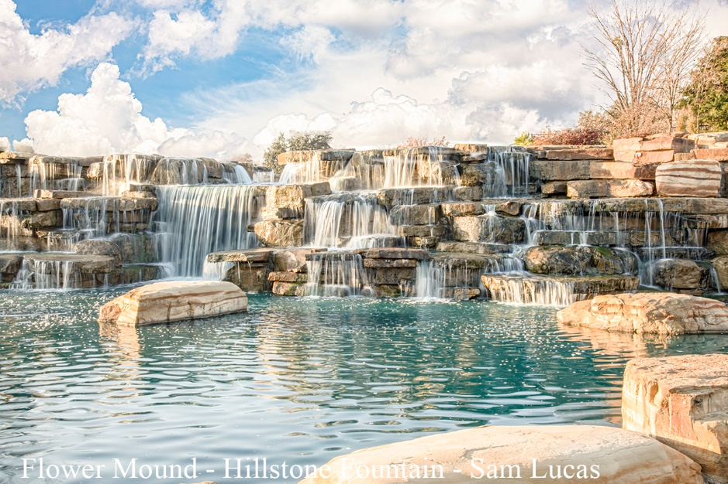
Note how the fountain is turned off | 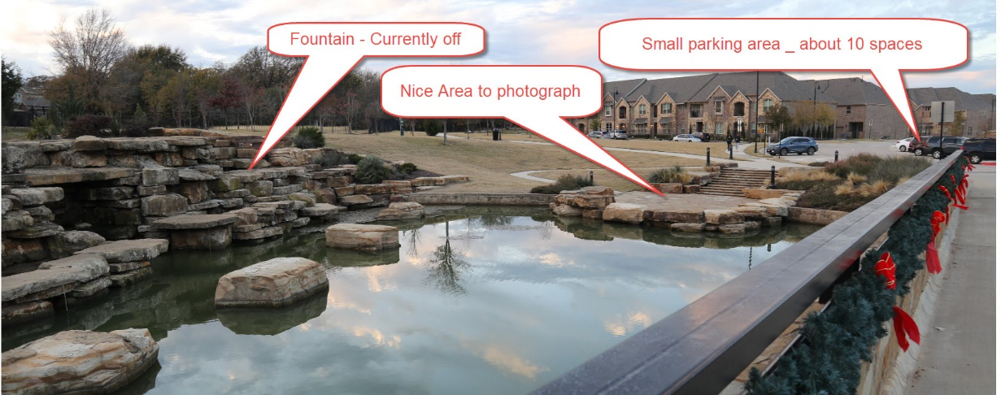
 | 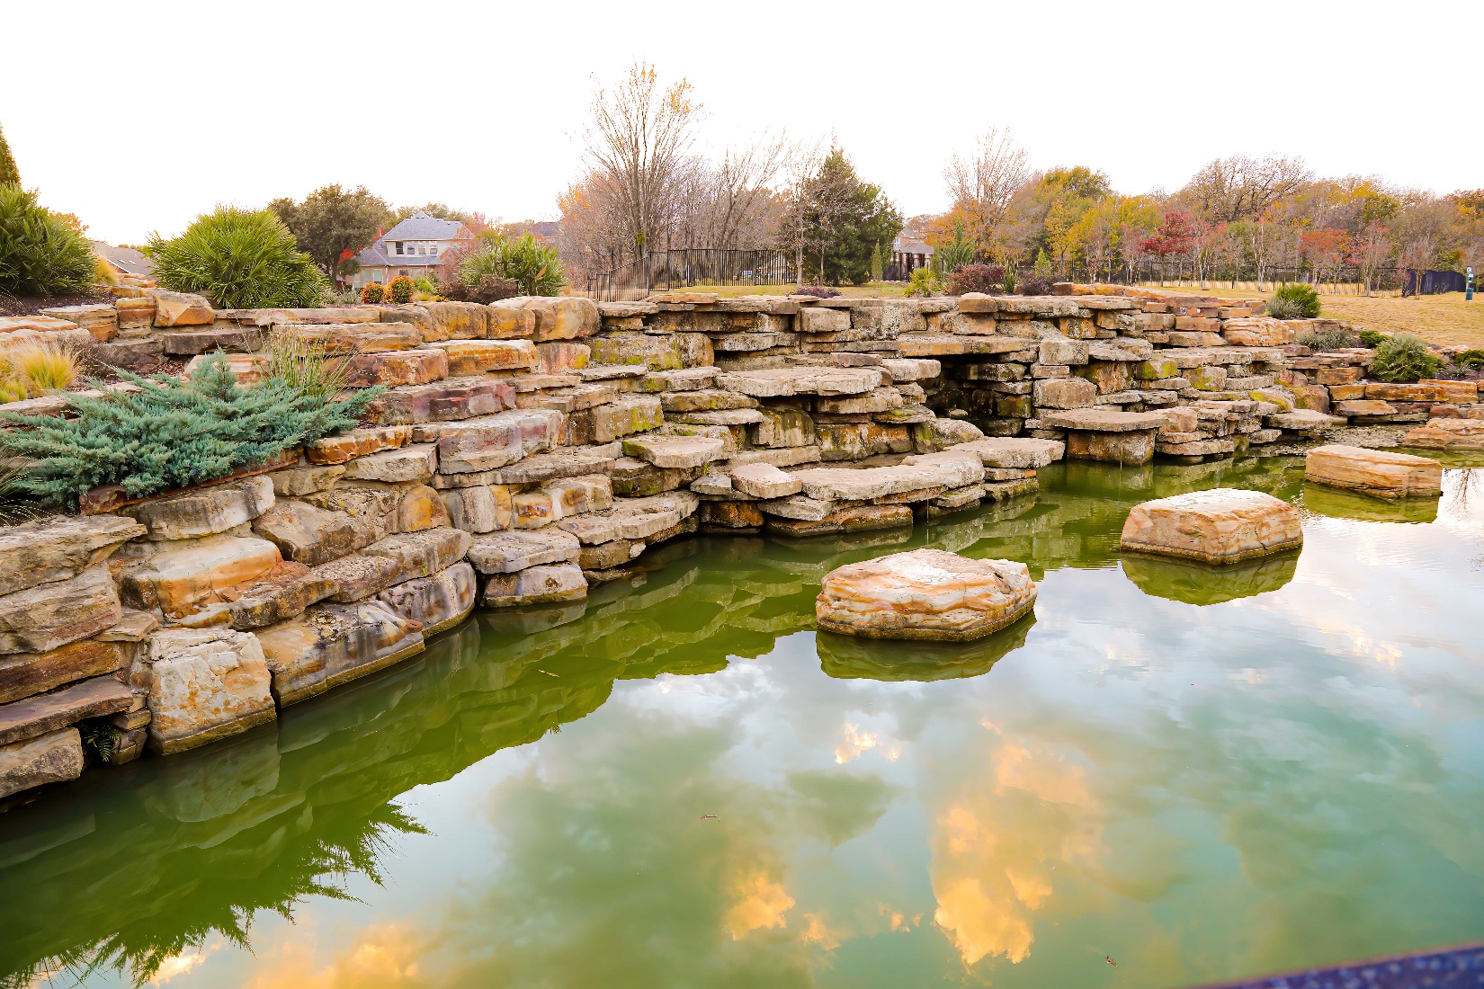

End of document

